TITLE OF PAPER (14 PT BOLD)
First Author¹ , Second Author² , Third Author^{3*} (12 pt)
Affiliation 1 (Institution, Department, Postal Code, Country). E-mail: (10 pt)
2Affiliation 2 (Institution, Department, Postal Code, Country). E-mail: (10 pt)
3Affiliation 3 (Institution, Department, Postal Code, Country). E-mail: (10 pt)
*Corresponding author E-mail: (10 pt)

Abstract. This document is an example of a contribution to be submitted for Al-Furat Journal of Innovations in Mechanical and Sustainable Energy Engineering (FJIMSE) from AL-Furat Al-Awsat Technical University. This is the abstract in font size: 12 pt with the heading in bold. Please use the Times New Roman font. The title is in size 14 pt Bold (all capital letters), the names of the authors are in size 12 pt and the name of the organization and its address are in size 10 pt. The abstract is written as one column text, single-space, font size 12, italic. The text is in single-space, typed in a one column layout and font size 12 pt. Please do not number the pages.

Keywords: Put 3 - 5 keywords here, keywords are separated by semi colon .

1. INTRODUCTION

Text text text text text text text text text text text text text text text text text text text text text text text text text text text text text text text text text text text text text text text text text text text text text text text text text text text text text text text text text text text text text text text text text text text text text text text text text text text text text text text text text text text text text text text text text text text text text text text text text text text text text text text text text text text text text text text text text text text text text text text text text text text text text text text text text text text text text text text text text text text text text text text text text text text text text text text text text text text text text text text text text text text text text text text text text text text text text text text text text text text text text text text text text text text text text text text text text text text text text text text text text text text text text text text text text text text text text text text text text text text text text text text text text text text text text text text text text text text text text text text text text text text text text text text text text text text text text text text text text text text text text text text text text text text text text text text text text text text text text text text text text text text text text text text text text text text text text text text text text text text text text text text text text text text text text text text text text text text text text text text text text text text text text text text text text text text text text text text text text text text text text text text text text text text text text text text text text text text text text text text text text text text text text text text text text text text text text text text text text text text text text text text text text text text text text text text text text text text text text text text text text text text text text text text text text text text text text text text text text text text text text text text text text text text text text text text text text text text text text text text text text text text text text text text text text text text text text text text text text text text text text text text text text text text text text text text text text text text text text text text text text.

2. MATERIALS AND METHODS

2.1. MATERIALS

Text text text text text text text text text text text text text text text text text text text text text text text text text text text text text text text text text text text text text text text text text text text text text text text text text text text text text text text text text text text text text text text text text text text text text text text text text text text text text text text text text text text text text text text text text text text text text text text text text.

Equation must be written in the equation editor of Microsoft Word and should be placed flush-left with the text margin. Equations are numbered consecutively starting from 1 as follows:

(1)

Text text text text text text text text text text text text text text text text text text text text text text text text text text text text text text text text text text text text text text text text text text text text text text text text text text text text text text text text text text text text text text text text text text text text text text text text text text text text text text text.

2.2. METHODS

Text text text text text text text text text text text text text text text text text text text text text text text text text text text text text text text text text text text text text text text text text text text text text text text text text text text text text text text text text text text text text text text text text text text text text text text text text text text text text text text text text text text text text text text text text text text text text text text text text text text text text text text text text text text text text text text text text text text text text text text text text text text text.

3. RESULTS AND DISCUSSION

3.1. RESULTS

Text text text text text text text text text text text text text text text text text text text text text text text text text text text text text text text text text text text text text text text text text text text text text text text text text text text text text text text text text text text text text text text text text text text text text text text text text text text text

3.2. DISCUSSION

Text text text text text text text text text text text text text text text text text text text text text text text text text text text text text text text text text text text text text text text text text text text text text text text text text text text text text text text text text text text text text text text text text text text text text text text text text text text text

4. CONCLUSIONS

The paper will not be reformatted, so please strictly keep the instructions given above, otherwise it will be returned for improvement. Please upload your paper in DOC file.

REFERENCES

The heading of the References section must not be numbered. All reference items must be in 12 pt font. Please use Regular and Italic styles to distinguish different fields as shown in the References section. Number the reference items consecutively in square brackets (e.g. [1]).
When referring to a reference item, please simply use the reference number, as in [2]. Do not use “Ref. [3]” or “Reference [3]” except at the beginning of a sentence, e.g. “Reference [3] shows …”.
Multiple references are each numbered with separate brackets (e.g. [2], [3], [4]–[6]).

- Author-X (last/family name), A. B. (first & middle initials), Title of the book, Publisher, City of publication, Page reference, Year.
- Author-Y, C. D., Author-Z, E. F., Name of the Journal / Proceedings, 83 (volume), 1526 (first page), 2019 (year).

Figure and tables
Figures and Tables Captions must be located after refrences at the end of the paper, typed in bold and should appear below the figures and above the tables. Please use the Times New Roman font 10pt to type table contents.

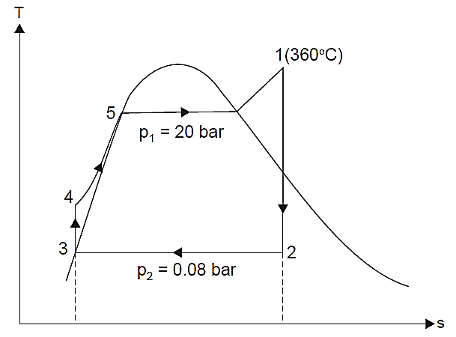

Fig. 1. Al-Furat Journal of Innovations in Agriculture Sciences. (10 pt)

Table 1. Table title. (10 pt)

