SDG 3: Good Health and Wellbeing

- From Najaf...the launch of the fourth edition of the International Scientific Conference on Medical and Biological Technologies, organized by Al-Furat Al-Awsat Technical University in partnership with the Dohuk Technical University.
From the Al-Najaf Al-Ashraf Governorate... Al-Furat Al-Awsat Technical University held its fourth international scientific conference for medical and biological technologies in partnership with the Dohuk Technical University, under the slogan “Medical technologies are our hope for a better tomorrow” for the period (17-18/4/2024).

The opening ceremony was attended by the President of the Al-Furat Al-Awsat Technical University, Professor Dr. Hassan Al-Zubaidi, and Dr. Masoud Abdel Karim, representing the President of the Dohuk Technical University, Professor Dr. Ari Adel, the President of the University of Kufa, Professor Dr. Yasser Lafta Al-Ugaili, the assistants to the President of the University, the deans of the formations of Kufa, Al-Najaf Al-Ashraf, Al-Diwaniyah, and Al-Rumaitha, and department directors. In the presidency of the university, as well as the senior staff at the Kufa Technical Institute, researchers and specialists from Iraqi universities in the center and region, and university employees and formations.

At the opening ceremony, Al-Zubaidi gave a speech in which he pointed out the importance of scientific research in developing the health and medical sector, pointing out that the university has achieved remarkable progress in the scientific research movement, as the number of published research in the Scopus and Clarivate database reached approximately (3,000) three thousand research papers, which contributed to the university’s entry into the university. In a number of prestigious international rankings locally, regionally and internationally, all of this would not have been possible if our university had not had an educational staff that made scientific research a slogan and a unique practice for their work.

He also stressed his encouragement of applied research that addresses real problems in various sectors of society, hoping that such qualitative conferences will continue to be held to strengthen the partnership between the two universities and to serve the educational process.

The conference aims to exchange experiences and learn about the latest developments in medical, health and biological science technologies, and research into typical diagnostic and therapeutic methods for treating diseases, in a way that enhances ways to improve the quality of health and therapeutic services in the fields of: medical laboratories, community health technologies, nursing and therapeutic pharmaceuticals.

At the end of his speech, he thanked the scientific committee and the participating researchers, hoping that their research would resonate widely for its application in practical reality. Thanks also go to the preparatory and media committee and all the supporting committees that contributed to the completion of this qualitative conference.

For his part, the Chairman of the Conference Preparatory Committee and Dean of the Technical Institute of Kufa, Professor Dr. Fadel Sami Zaghir, indicated that the conference presented (61) sixty-one research working papers, including papers outside Iraq submitted by international universities, and others from Iraqi universities in the center and the region, and key speakers were approved. This scientific conference was from the Arab Republic of Egypt, and the third and fourth were from the University of Zakho and the Technical University of Dohuk.

It is noteworthy that the conference topics included medical laboratory techniques, community health techniques, nursing techniques, pharmaceutical and therapeutic techniques, and diagnostic and therapeutic techniques.

A documentary film was shown about the university, its formations, and the renaissance of sustainable construction and reconstruction therein. A documentary film about the Technical University of Dohuk was also shown.

While the opening session included the presentation of two working papers by the main speakers, the first from the Arab Republic of Egypt, Professor of Psychiatry at Ain Shams University, Dr. Hanan Azzam, entitled “Autism Spectrum - Bridge Theory and Application” and another working paper entitled “The Microbiome” by Professor Dr. Khaled Sobhi Ibrahim, in addition to working papers presented. Of the Iraqi universities in the center and the region.

At the conclusion of the activities of the first day of the conference, the University President extended his thanks and appreciation to all the professors, researchers and graduate students who contributed to enriching the conference.

In the same context, Al-Zubaidi presented the university shield to the representative of the President of the University of Dohuk, Professor Dr. Aari Adel, the representative of the University of Dohuk, Dr. Masoud Abdul Karim, Dean of the College of Health and Medical Technologies in Sheikhan, and the official spokesmen and heads of the scientific and preparatory committees from the University of Dohuk. The President of Al-Furat University was also honored. Technical Center, assistants to the university president, Professor Dr. Fadel Sami Zaghir, dean of the Kufa Technical Institute, head of the conference’s preparatory committee, and gentlemen, the official speakers and heads of the scientific and preparatory committees, by the representative of the president of the Technical University of Dohuk.
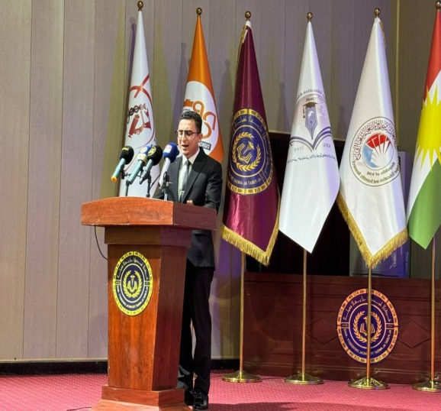
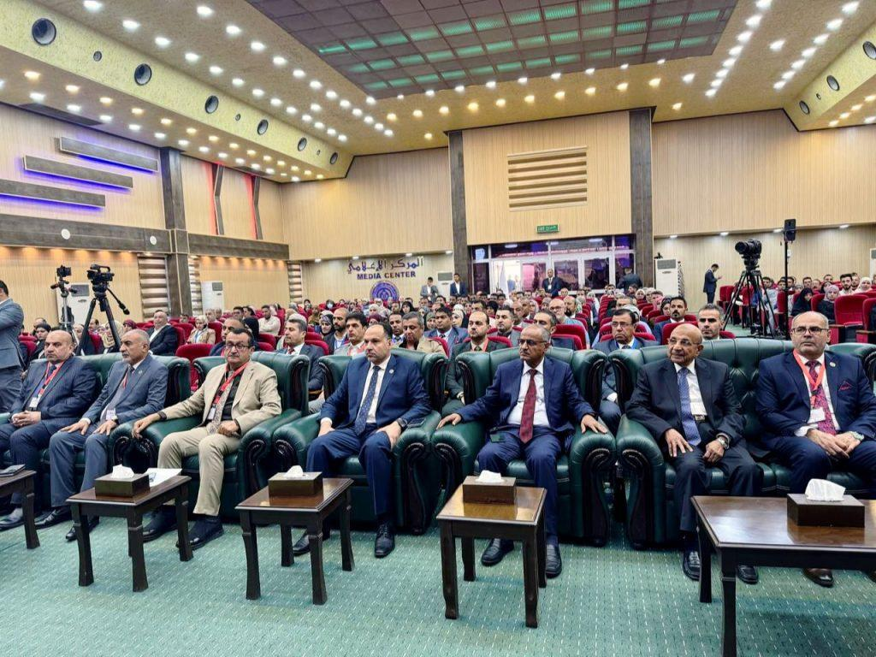

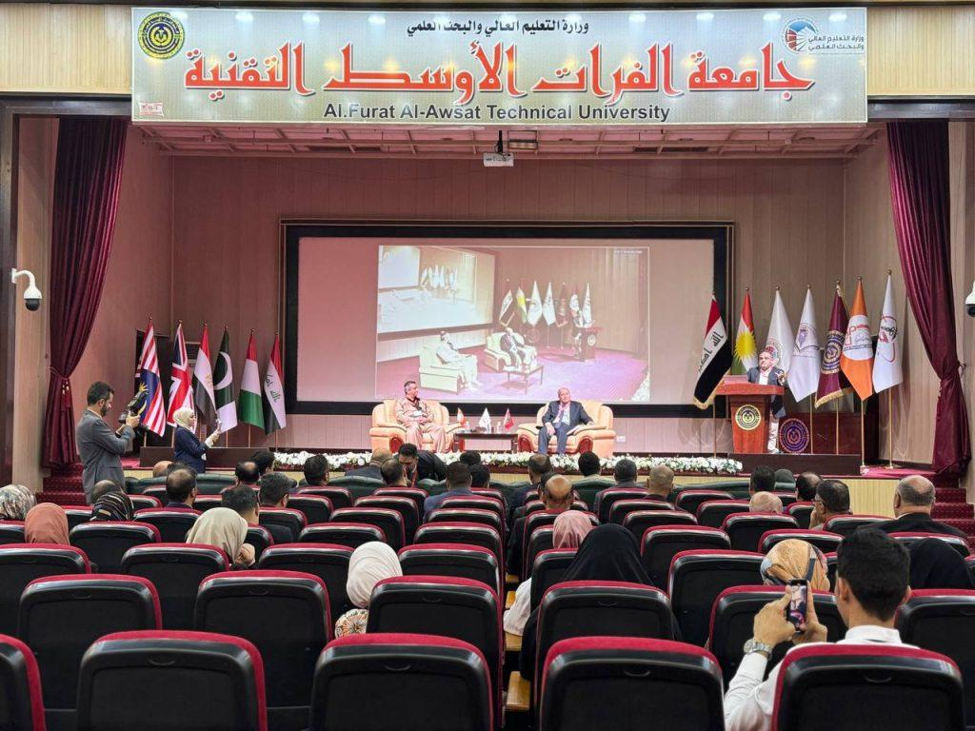

- Al-Furat Al-Awsat Technical University organizes a training course on medical rehabilitation and physical therapy entitled (Vestibular Rehabilitation(
The Department of Medical Rehabilitation and Physical Therapy at the College of Health and Medical Technologies, Kufa, at Al-Furat Al-Awsat Technical University organized a training course on medical rehabilitation and physical therapy entitled (vestibular rehabilitation). The President of Al-Furat Al-Awsat Technical University, Professor Dr. Hassan Latef Kadhim Al-Zubaidi, attended part of the course, which lasted for two days. With the participation of specialists and researchers in the field of physical therapy from various governorates of Iraq. The international trainer, Dr. Redha Dashti, a neurology consultant from the miserable Kingdom of Bahrain, explained that the course aims to introduce physical therapists to modern techniques for evaluating and treating benign paroxysmal positional vertigo (BPPV), unilateral (UVH) and bilateral (BVH) vestibular dysfunction, as well as introducing neck vertigo. The course discussed the most important causes of vertigo and the most common symptoms that inner ear patients suffer from. The course also discussed the concept of benign paroxysmal positional vertigo (BPPV), the most common pathological condition in the ear, nose, and throat department, its symptoms, and methods of treatment and prevention. For his part, the university president honored the international trainer. With a certificate of appreciation and the university’s shield for his distinguished scientific efforts. The symposium was attended by the Assistant to the University President for Scientific Affairs, Professor Dr. Ahmed Ghanem Waday, the Dean of the College, Professor Dr. Angham Jassim Al-Ramahi, and the Director of the University President’s Office, Mr. Moin Mohsen Al-Rubaie..
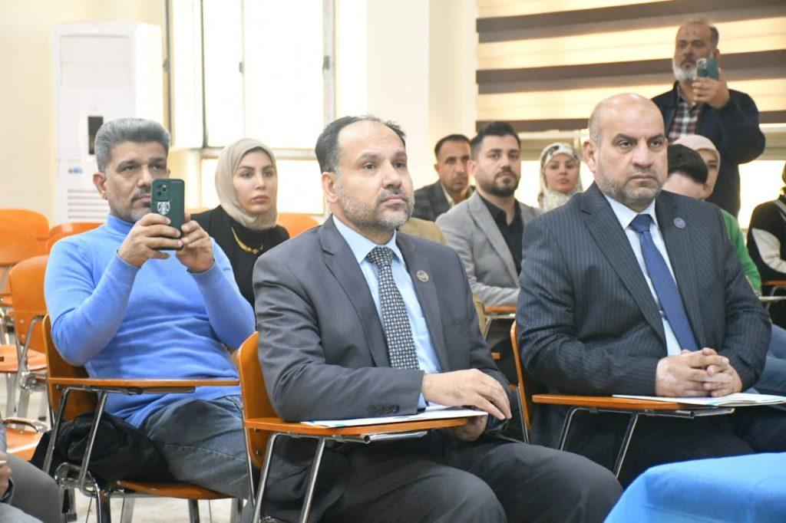
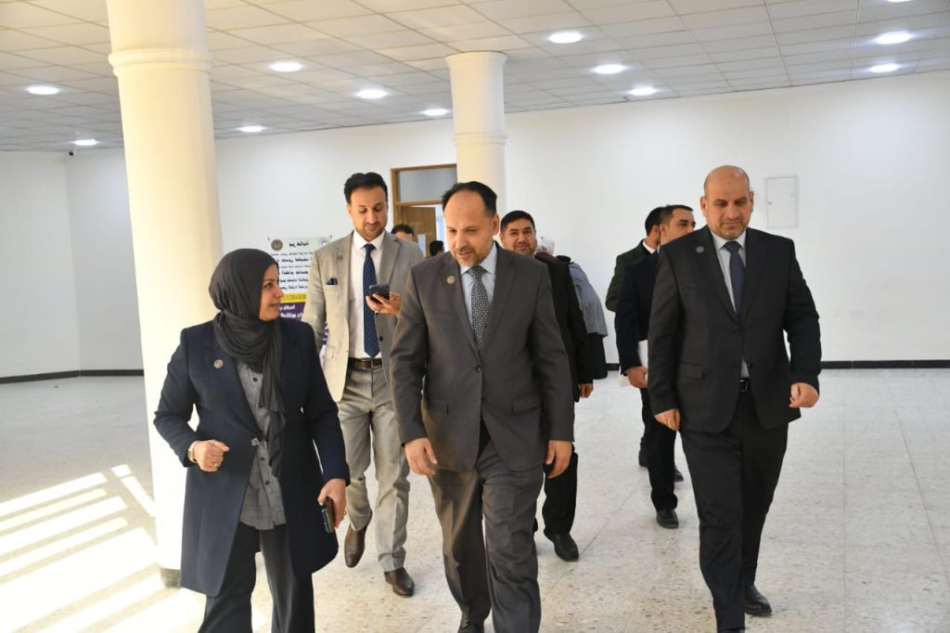

- Holding the third edition of the International Scientific Conference on Medical and Biological Technologies, organized by Al-Furat Al-Awsat Technical University in partnership with the Dohuk Technical University in the Kurdistan region of Iraq.
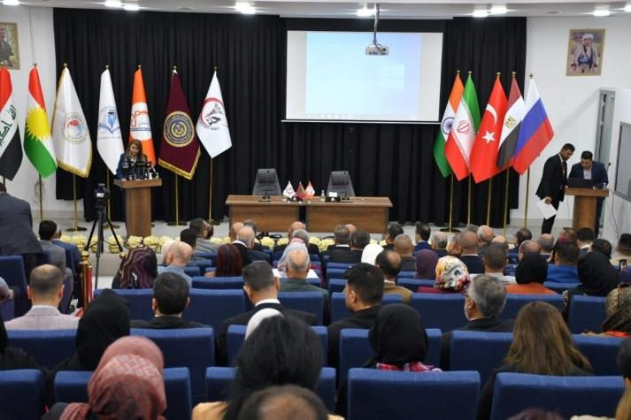
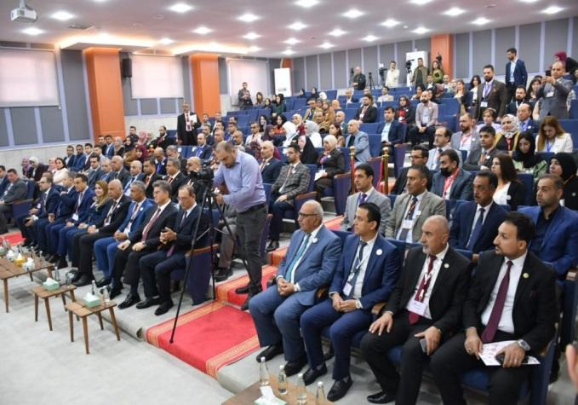

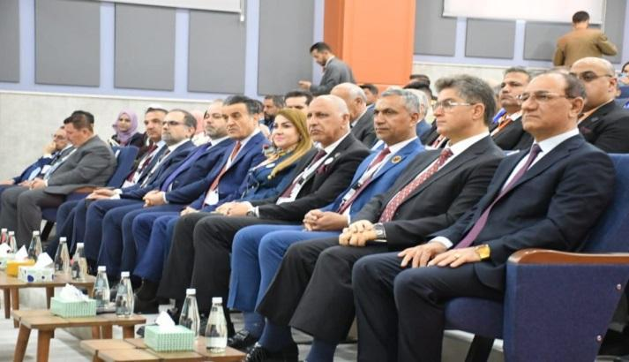
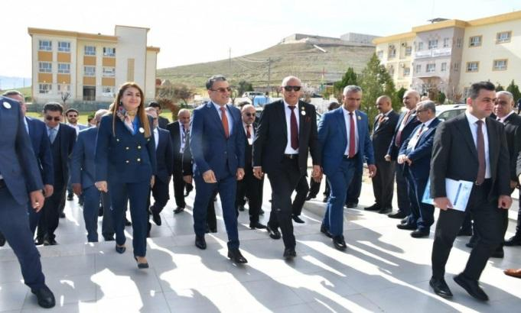

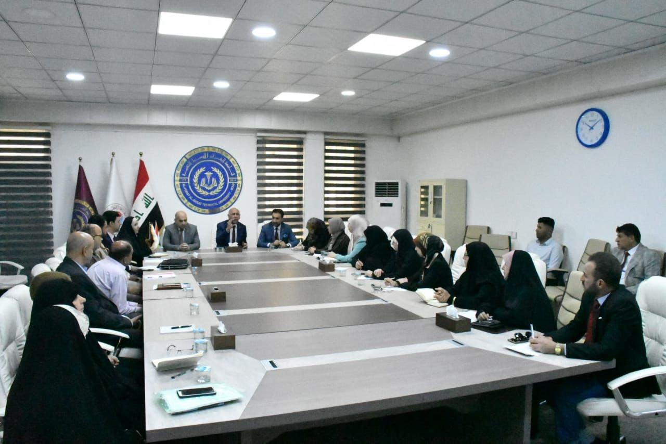
- Holding workshops on the role of psychological counseling and educational guidance units in student behavior

- Opening of the building of the Prosthetics Department to help disability people and the Information Technology Unit.
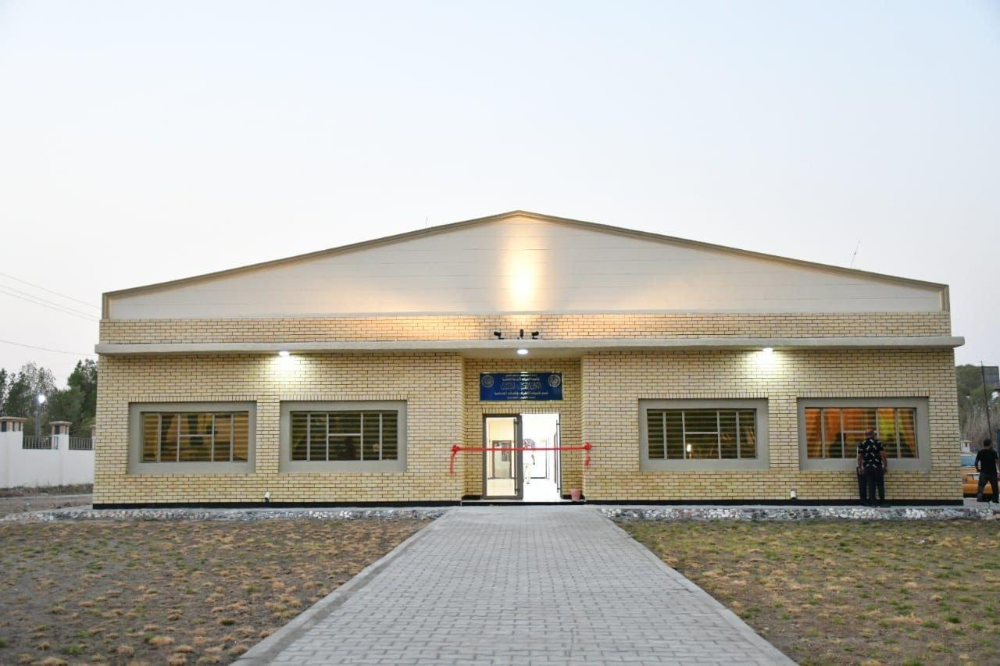

- A number of people with disabilities and special needs were presented with artificial limbs that were manufactured in the workshops of the Limb and Support Manufacturing Techniques Department

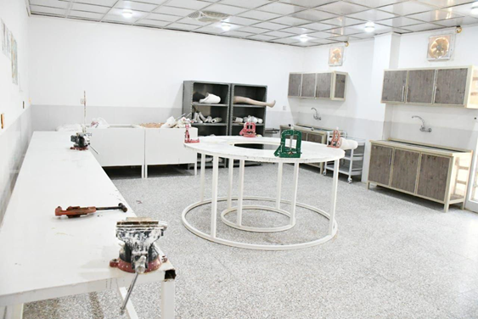

Ensuring healthy lives and promoting well-being for all at all ages. Targets include reducing maternal mortality; Ending preventable child deaths; ending or reducing AIDS and other diseases; universal health coverage, affordable essential medicines, and sexual and reproductive health care; Vaccine research, and access to medicines. Health sustainability aims to improve health and safety in the workplace by providing health and preventive care. The following activities were implemented at university sites:

At the Najaf Technical Institute, many seminars and workshops were held on drugs and their harm to health and society, communicable diseases and pollutants in the environment, and a number of seminars on topics related to health.
At the Samawa Technical Institute, it continued to provide free health services to different groups of society In village and rural areas and for the institute’s students, as well as carrying out voluntary health campaigns for schools at various educational levels and holding many workshops and seminars on the unhealthy phenomena that are widespread in society. Alcohol and drugs and their impact on the health of society, as well as electronic communication

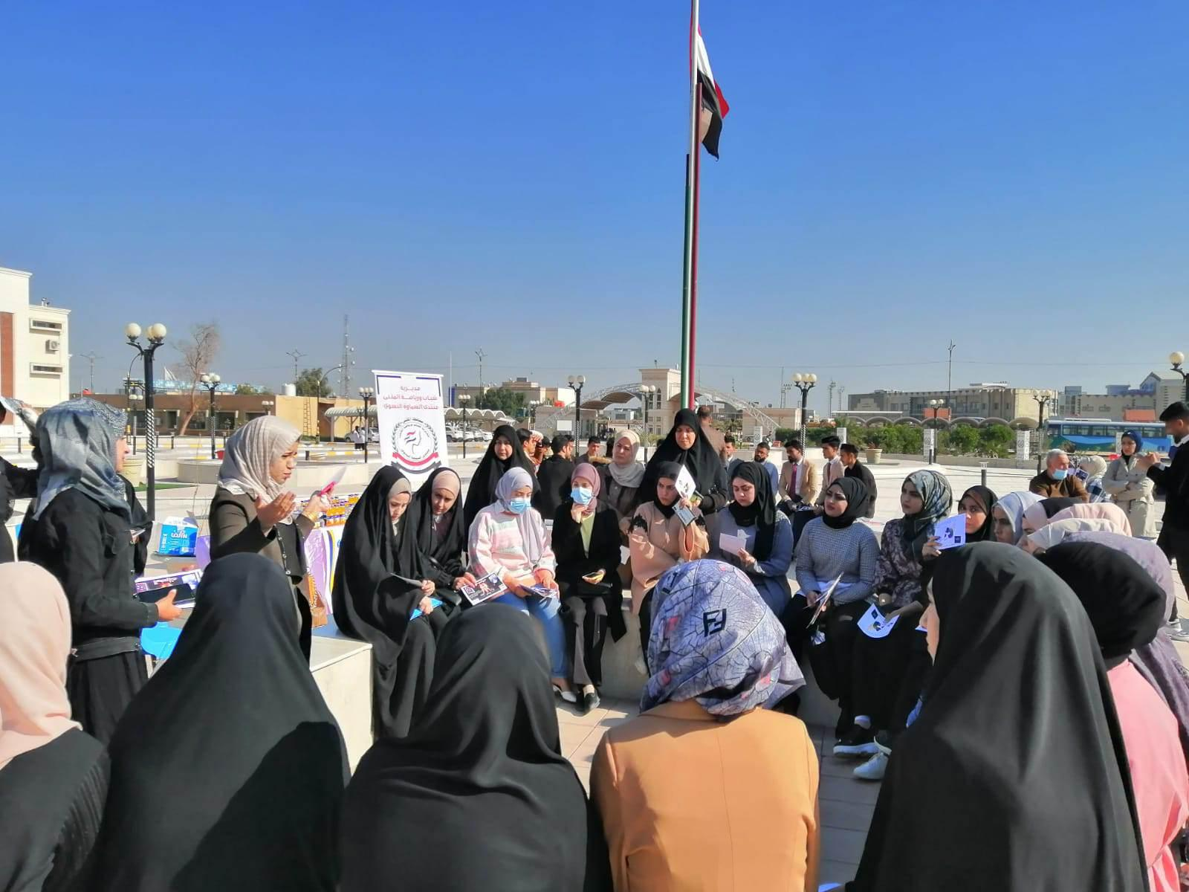Awareness workshops on widespread phenomena in society
As for the College of Medical and Health Technologies, it provided academic activities represented by seminars, workshops, and specialized courses in the field of health and the healthy environment, as well as providing free health services to different groups of society, including visiting oncology patients at the Al-Furat Al-Awsat Oncology Hospital in Al-Najaf Al-Ashraf Governorate, and donating the purchase of medicines at a cost of (250,000) dinars for patients. , Conducting free field laboratory tests for traffic policemen in Najaf GovernorateIt was completed Completion of 13 medical courses to maintain good health, 11 seminars, 1 workshop, and 1 seminar.
At the Karbala Technical Institute, the institute’s members are making great efforts to contribute to achieving the goal of good health and well-being by holding many seminars and workshops related to health for its members, students, and segments of society, as well as seeking the assistance of employees of the relevant state to participate in them.
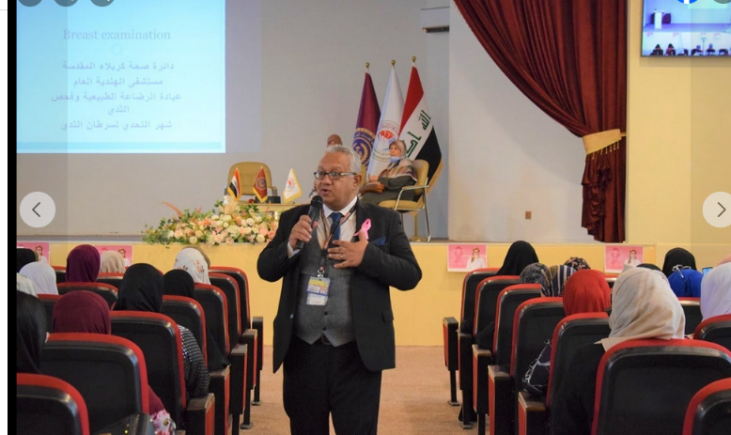
Seminar on drugs
At the Technical Institute of Kufa, a research team from the Medical Laboratory Technology Department visited some rural schools in Najaf Governorate to distribute some detergents to students (detergents) that were produced in the department’s laboratories. The Medical Laboratory Technology Department organized a volunteer campaign that included carrying out several medical examinations (CBC, G.U.E., G.S.E) for various groups of the university community, with a ratio of (40) people distributed between students and associates.
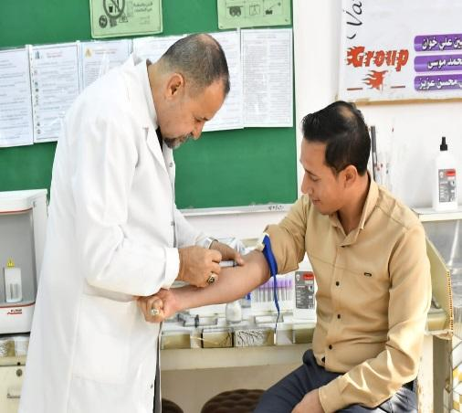
The Nursing Technology Department organized a training course on first aid for burns
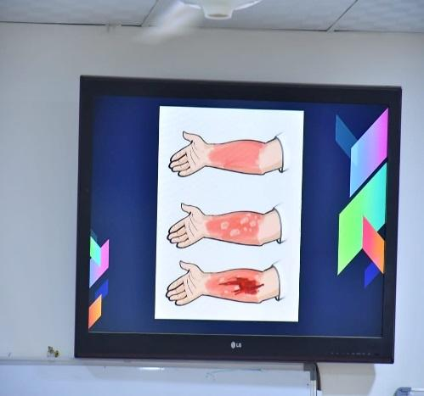
In addition to holding many workshops and courses on drugs, electronic extortion, and topics related to public health, with (29) workshops and seminars.
As for the Diwaniyah Technical Institute It ran out The Limb and Support Manufacturing Techniques Department held a course entitled “Isolation and Diagnosis of Contaminated Bacteria for Infections Leading to Amputation.” The Limb and Support Manufacturing Techniques Department at the Institute held a course entitled (Negative Effects of Drugs, Toxins, and Psychotropic Substances).

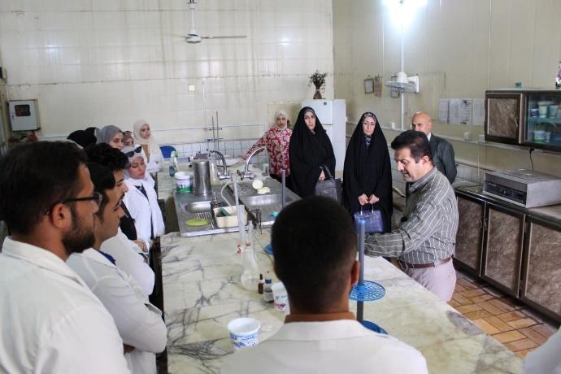
The Health Management Technologies Department at the institute held a symposium entitled The Dangers of Electronic Cigarettes, and the Community Health Technologies Department held a course entitled The Effect of Medicines and Nutritional Supplements on the Results of Laboratory Analysis.
At Al-Musayyib Technical College, many (4) courses were held on health education and health awareness, in addition to three seminars on drugs and their harms to health, and three seminars and workshops on smoking, the effect of jungles on human life, herbal medicine, and the medicinal benefits of plants.
At the Technical Administrative College, it held multiple symposiums on the negative effects of smoking and disorders resulting from drug abuse, their legal and societal consequences, the importance of rehabilitating those recovering from drug abuse, and the health effects of drug abuse as a case study, and a symposium on the general causes of the widespread phenomenon of drug abuse and reducing it. At the Technical Institute In Babylon, many workshops and seminars were held on the effects of drugs, their impact on health, the phenomenon of their spread, and methods of treatment from them, as well as on the harms of smoking, and the establishment of a medical detachment to provide medical services to visitors of the Arba’in shrine of Imam Hussein (peace be upon him) for free. Likewise, courses, workshops, and seminars on drugs, smoking, electronic blackmail, and on the province were carried out. On health at the Technical Institute of Al-Musayyib, Al-Rumaitha, and the Technical College of Engineering, Najaf.

A.M.D.Abdullah Fazil Sarheed

12- The Department of Plant Production Technologies, in cooperation with the Continuing Education Unit at Al-Musayyib Technical College, conducted a workshop on (the effects of drugs on the individual and society and how to get rid of them). The workshop aimed to introduce the attendees to drugs and addiction, the most important negative effects and complications resulting from addiction, and ways to prevent and treat drugs. It was conducted. Discussing the signs of an addicted person, the types of drugs, whether plant-based or manufactured in a laboratory, and methods of prevention and treatment. Target group: graduate and undergraduate students and employees in general.

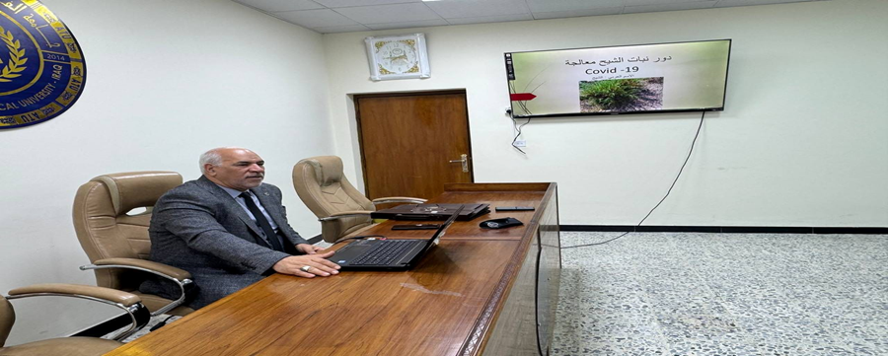
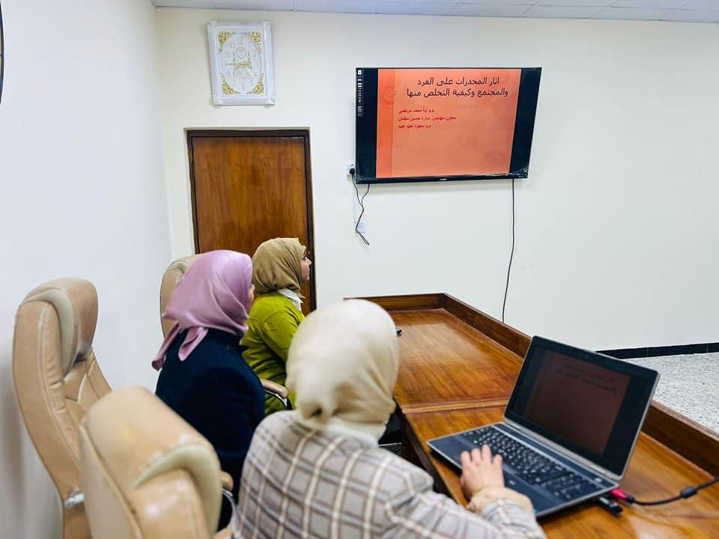

13- The Educational Guidance Unit at Al-Musayyib Technical College, one of the formations of Al-Furat Al-Awsat Technical University, organized, in cooperation with the Association of Educational Teachers, Babylon Branch, and the University of Babylon - College of Education for Human Sciences, a symposium on self-confidence among university students, in which he attended.
Dr. Naglaa Ali Sultan
M.D. Saad Marza Al-Hasnawi
The two lecturers pointed out that self-confidence is one of the important qualities that an individual must possess, as it helps a person deal with life in a positive manner and makes him more capable of overcoming challenges and difficulties. Therefore, self-confidence greatly affects a person's quality of life and his level of happiness and success in various fields.
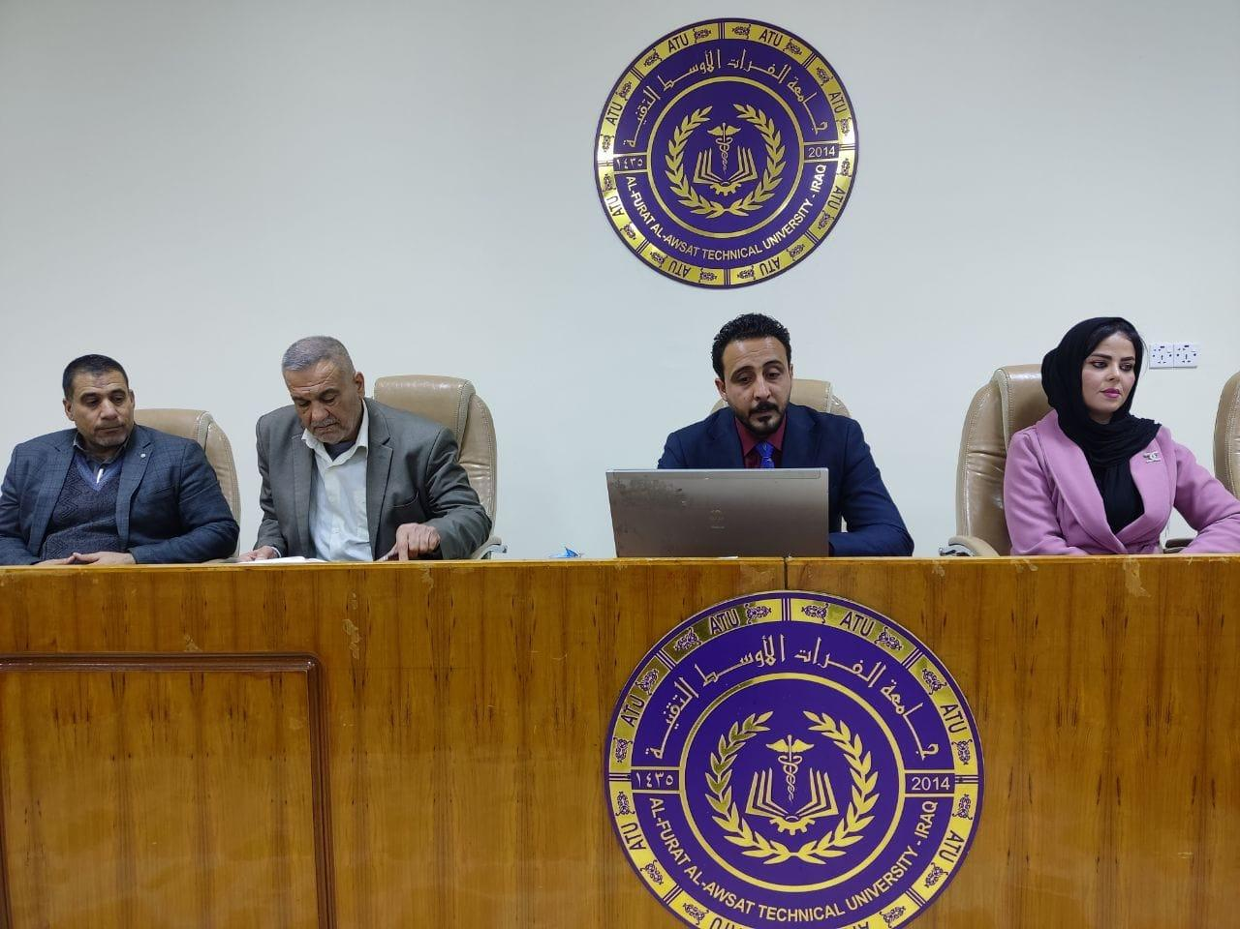

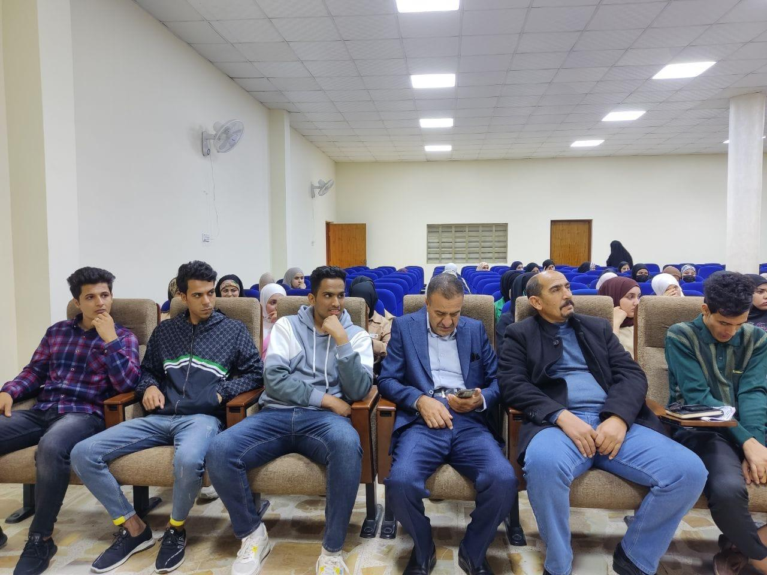

14- Al-Musayyib Technical College at Al-Furat Al-Awsat Technical University, in cooperation with the Mahaweel Drugs Division, organized an educational and awareness lecture for college students about the dangers of drugs and their effects on the individual and society. The lecture presented by Lieutenant Colonel Ali Hamid Hadi aimed to explain the dangers of drug addiction to the health of the individual and its effects on the family and society, and that practicing Addiction has a very significant impact in pushing a person to commit various crimes.
It included several topics, including the legal ruling for the user, identifying the types of narcotic substances and their effect on the person, the way they are promoted by drug dealers, and their negative consequences for the individual user in particular, as well as the social harms to society in general.
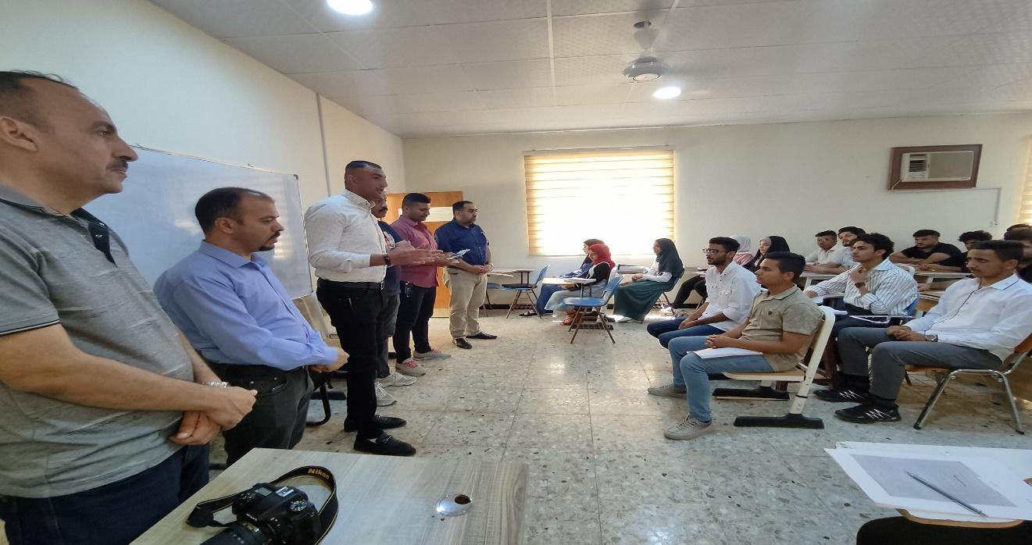
He recommended the necessity of issuing deterrent laws for the promotion and trade of drugs and the importance of educating the family and taking its role in guiding children, as well as educating society about the dangers of drugs by holding specialized seminars, courses and workshops. Follow the treatment methods for the addict and take a role for the family in this field.

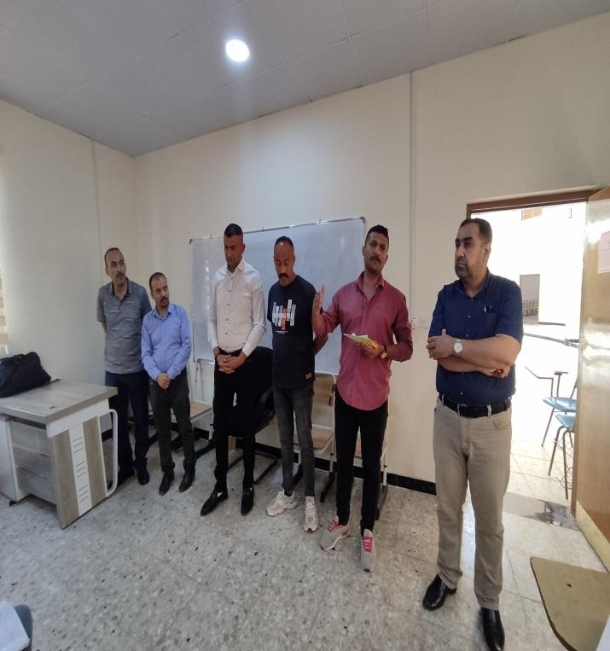
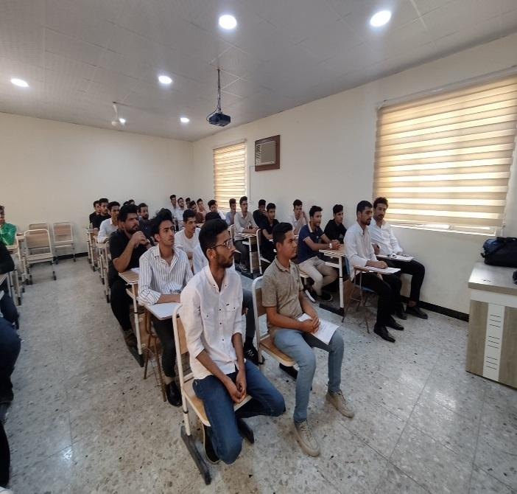
15- Al-Musayyib Technical College, the Continuing Education, Rehabilitation, Employment and Follow-up Unit, in cooperation with the Narcotics and Psychotropic Substances Division in Alexandria, organized an extensive symposium on drugs and their effects on the individual and society. The symposium aimed to raise awareness of the dangers of drugs and their impact on the individual’s condition in the family and society. It included several topics, the most important of which was the definition of drugs, the reasons for their promotion and use, their types, and methods of prevention. The symposium, in which First Lieutenant Osama Khudair Abbas lectured, touched on explaining the truth about drugs and their types, warning against their abuse, defining the reasons for their abuse and promotion, explaining their dangers to the individual, society, and the state, and introducing ways to prevent them. This bad phenomenon, its treatment, and highlighting the efforts made to address it by all concerned parties.
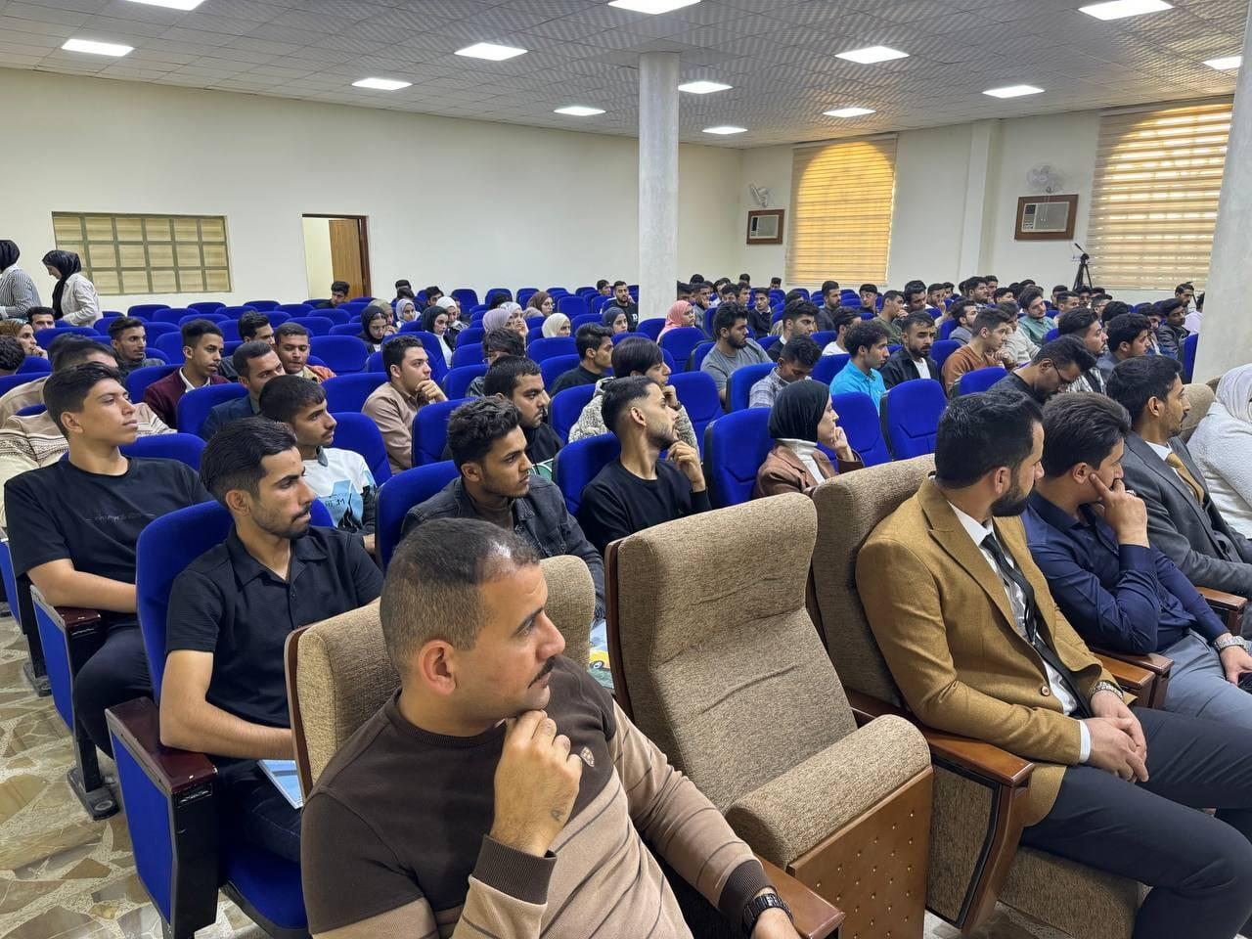
He explained that drug abuse is personal and public, and that the causes of drug use are ignorance of them and their effects, weak religious faith and upbringing, poor social status, imitation, bad company, and behavioral deviation. He explained that the ways to prevent drugs are to spread awareness of their dangers, harms, and effects, and explain the role of community institutions (family, school, media) in prevention. Among them is through awareness, in addition to the efforts of the security authorities in preventing them. The symposium explained the legal provisions for anyone who deals, deals, or trades in them, including imprisonment. The necessity of cooperating with the security services with news about suspected cases was emphasized.

16- Al-Musayyib Technical College/Educational Guidance Unit, in cooperation with the Directorate of Narcotics and Psychotropic Substances Affairs in North Babylon, organized a symposium on the phenomenon of the spread of drugs and its impact on the individual and society, in the presence of the college’s professors and students, where the lecture was given by jurist Colonel Mahdi Abdel Jalil Naas. The symposium aimed to raise awareness of the dangers of drugs, their effects, and how to treat addiction to them. During the symposium, he explained the phenomenon of drug abuse, its impact on the individual and society, its types, its impact on the body, and its health, psychological, and physical damage, as well as its impact on the family, pointing to the role of the family in protecting its children by listening to them, giving them time and attention, and setting clear rules. The symposium reviewed how we confront the problem of drugs, problems and difficult times without using drugs, knowing the truth of the problem, the degree of interest in it, adequate knowledge of its details, and how to obtain information that helps understand it and find a solution to it.

health
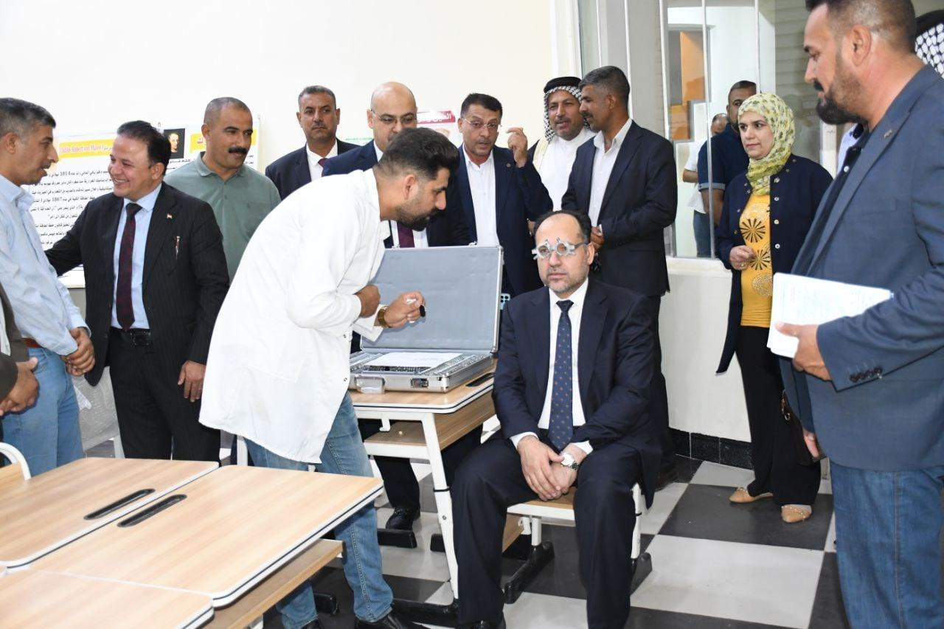
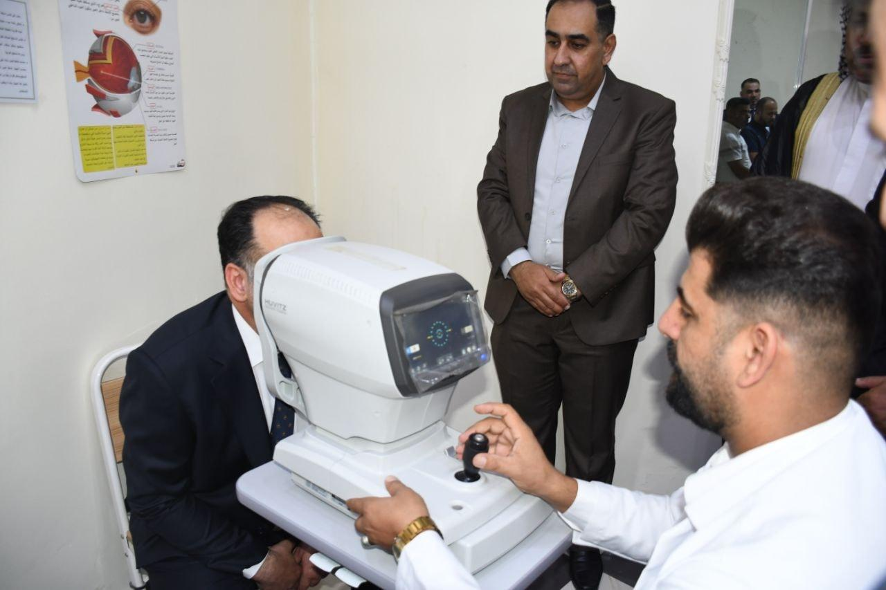

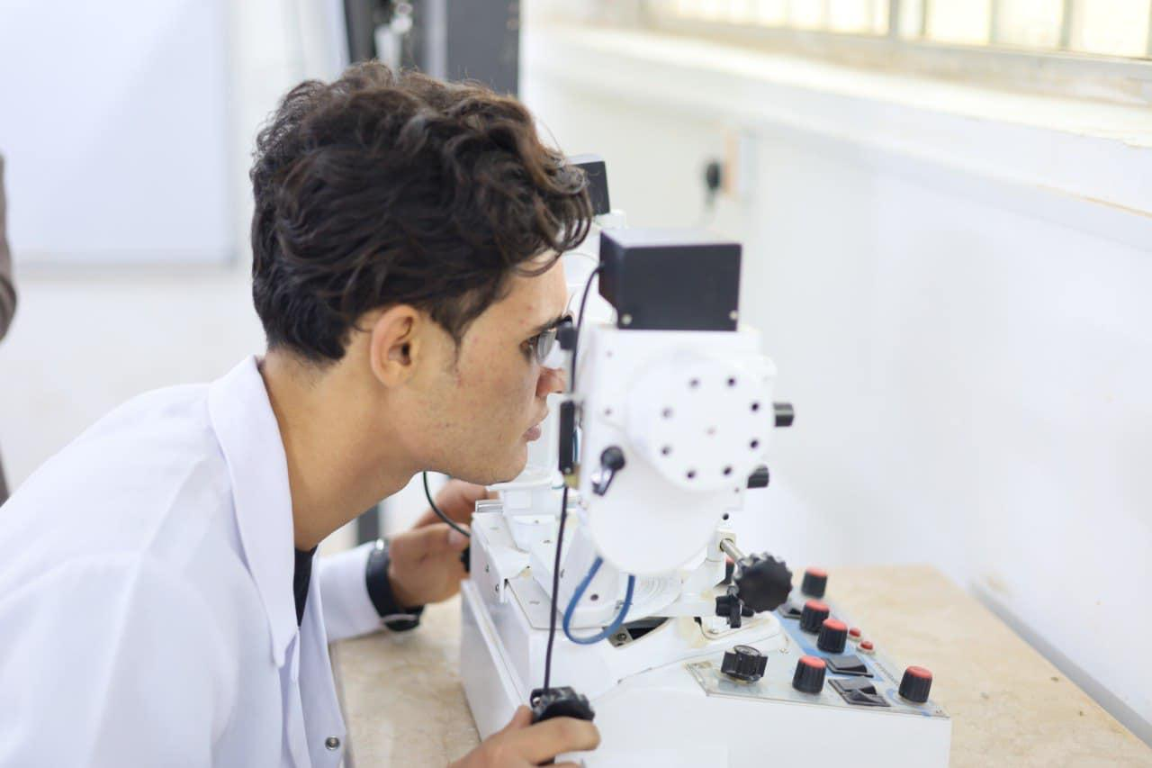
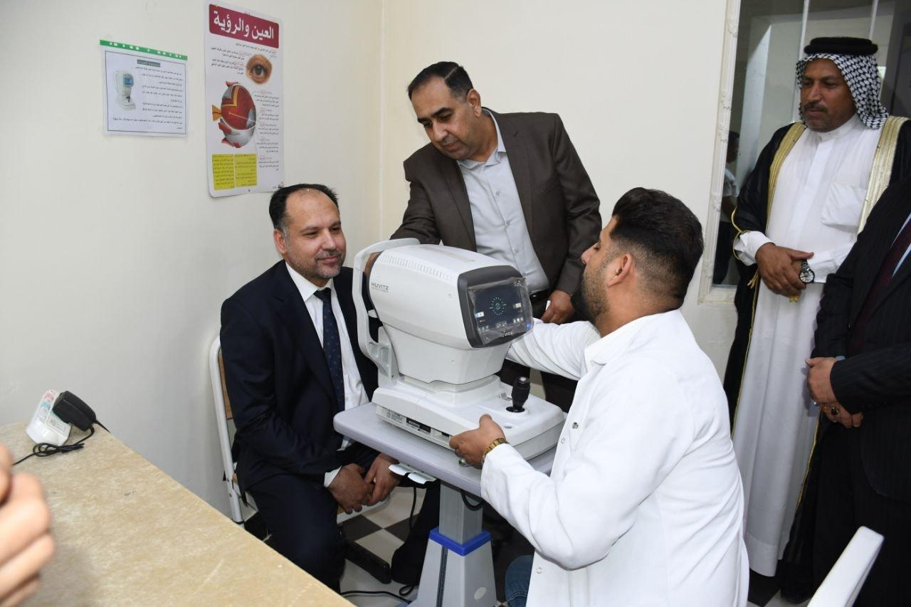

17- In compliance with the directives of the Ministry of Higher Education, the Musayyib College of Technology adopts a policy of prohibiting smoking inside the corridors of the buildings of the Musayyib Technical College by posting warning signs inside the building corridors..
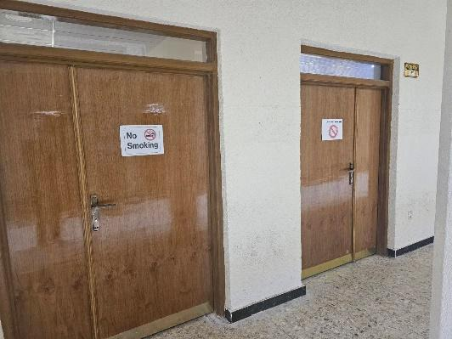

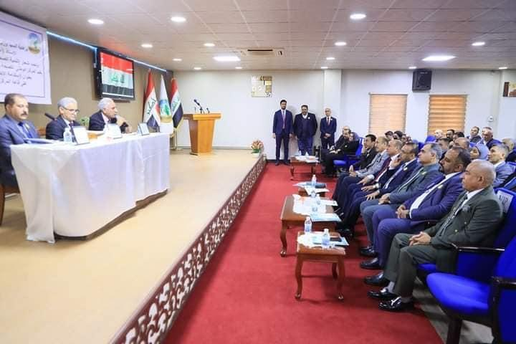
18- Participation of a lecturer (Prof. Dr. Adel Obaid Hassouni Al-Saadi) as a member of the scientific committee of the conference (Developing Occupational Health and Safety to Prevent Risks)
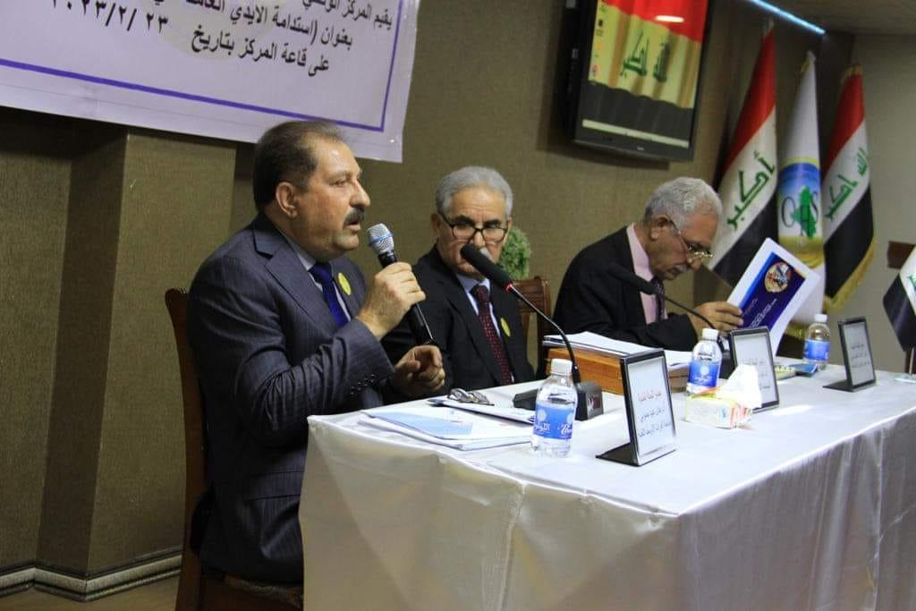

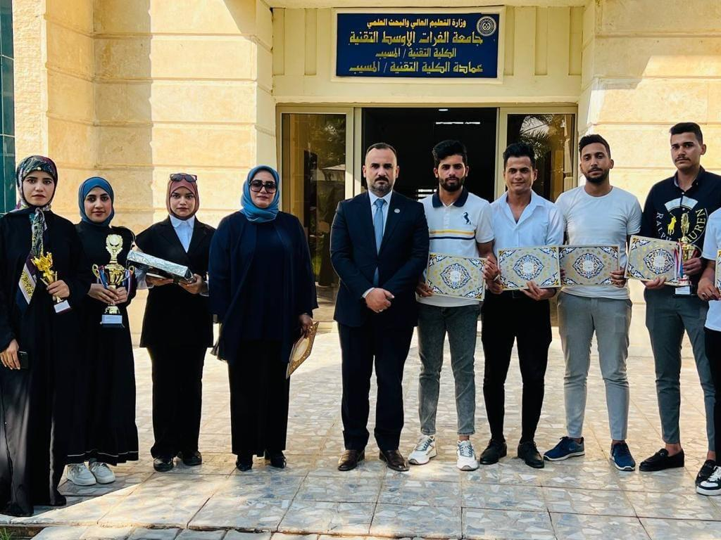
19- Students of Al-Musayyib Technical College participate in many festivals and sporting activities, where Students from Al-Musayyib Technical College won second place in the chess tournament and third place in the table tennis tournament that was held at the Karbala Technical Institute within the internal curriculum of Al-Furat Al-Awsat Technical University.
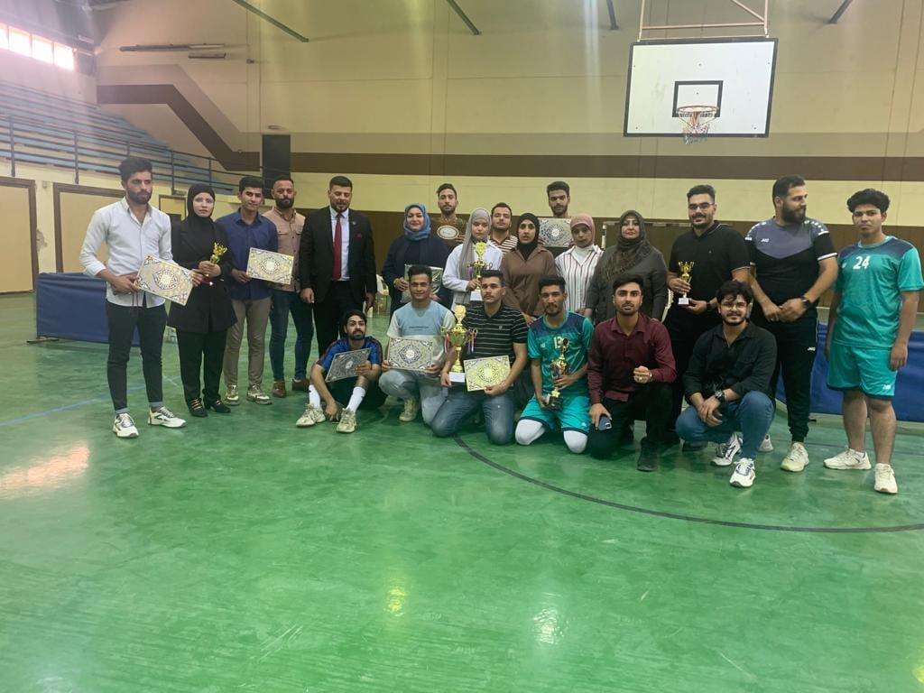

20- Students of Al-Musayyib Technical College participate in many festivals and sporting activities, where Students from Al-Musayyib Technical College won first place in the volleyball tournament.

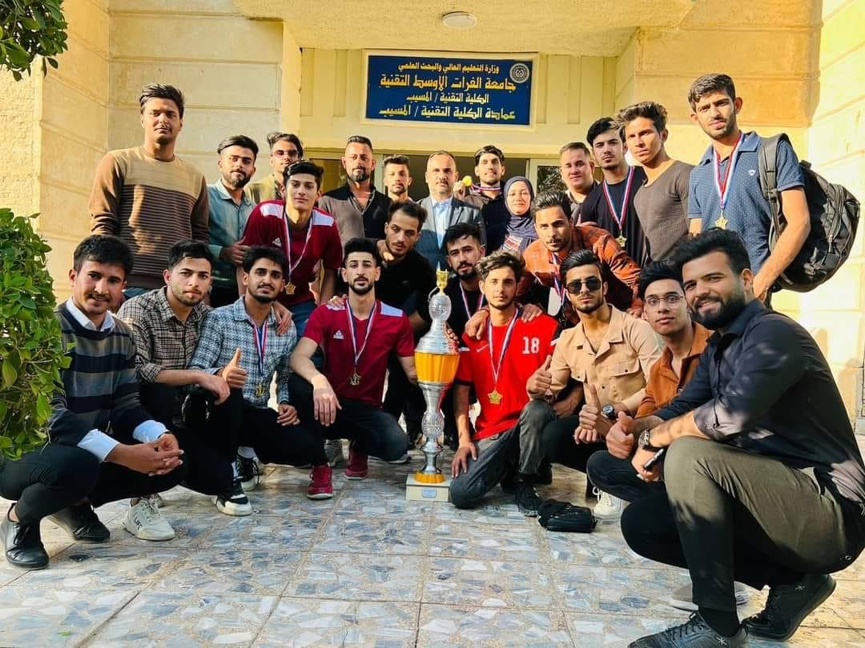
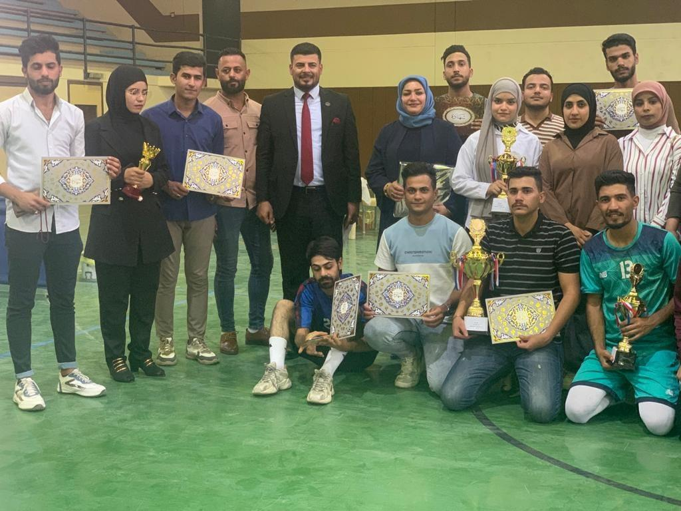

21- The Student Activities Division at the Al-Musayyib Technical College at Al-Furat Al-Awsat Technical University held a ceremony to honor the students participating in the nineteenth Siblings Meeting Festival, which was held at the global station in Baghdad and in the presence of the preparatory committee, Professor Abbas Al-Dakhil, where the students were honored by the Assistant Dean for Scientific Affairs, Dr. Nabil Hamid Abdel Majeed. On behalf of the Dean of the College, Dr. Ali Al-Zubaidi, Al-Furat Al-Awsat Technical University won second place in this festival over Iraqi universities, and certificates of appreciation were distributed to the participants. It is noteworthy that the festival is held annually in Baghdad with the participation of Iraqi universities, institutes, civil society organizations, and state institutions.

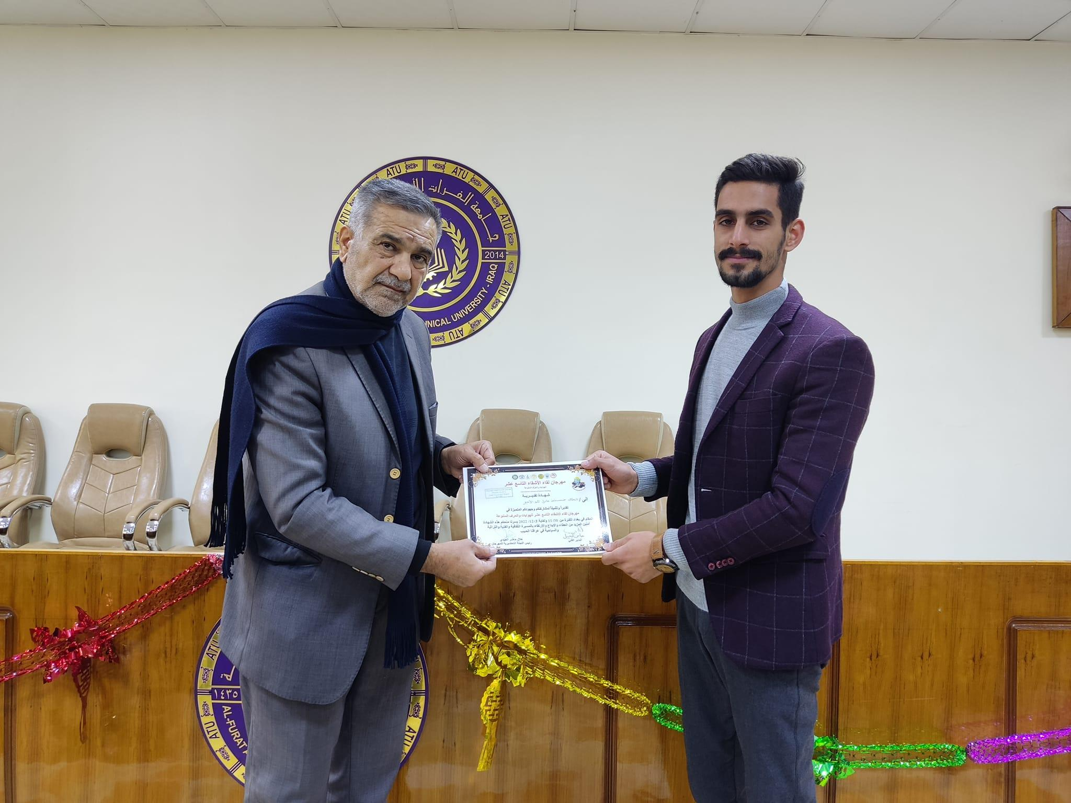
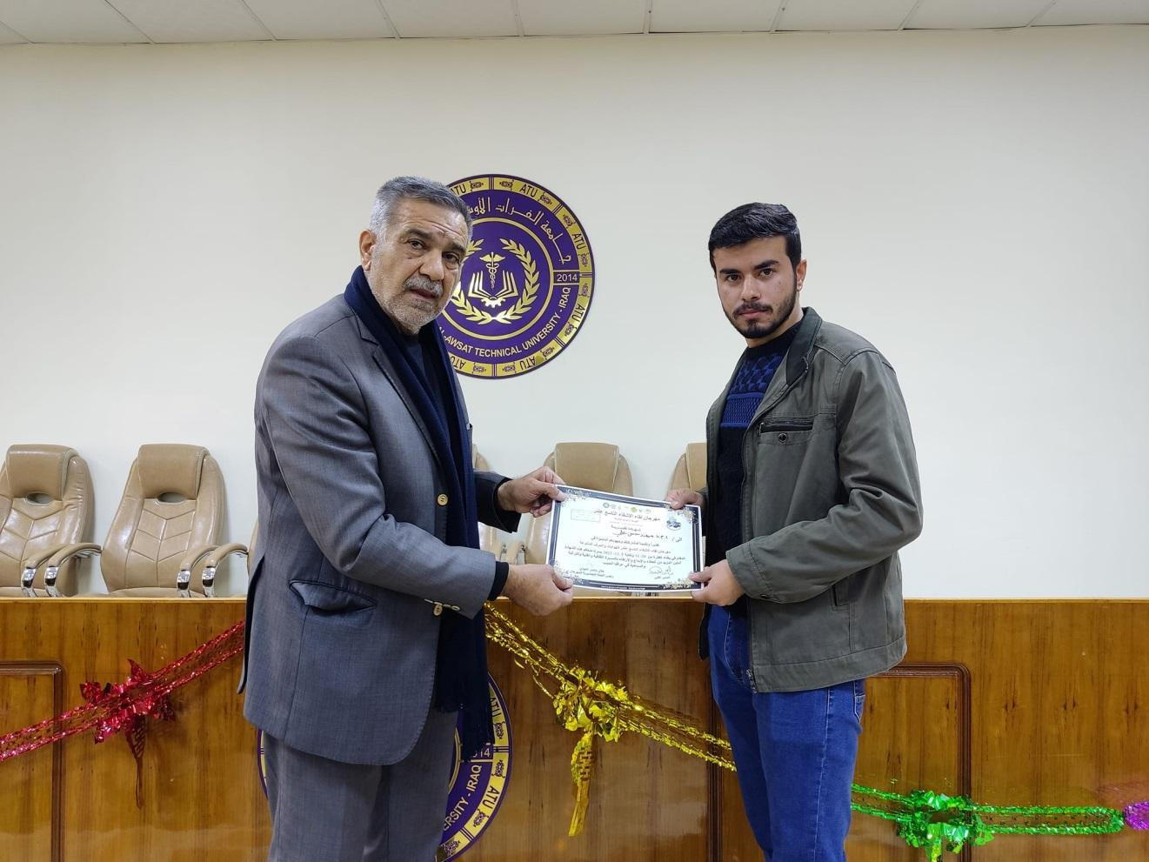

Technical Institute / Kufa

- The answer to the second point is below
- A research team from the Medical Laboratory Technology Department visited some rural schools in Najaf Governorate to distribute some detergents to students (detergents), which were produced in the laboratories of the above department.
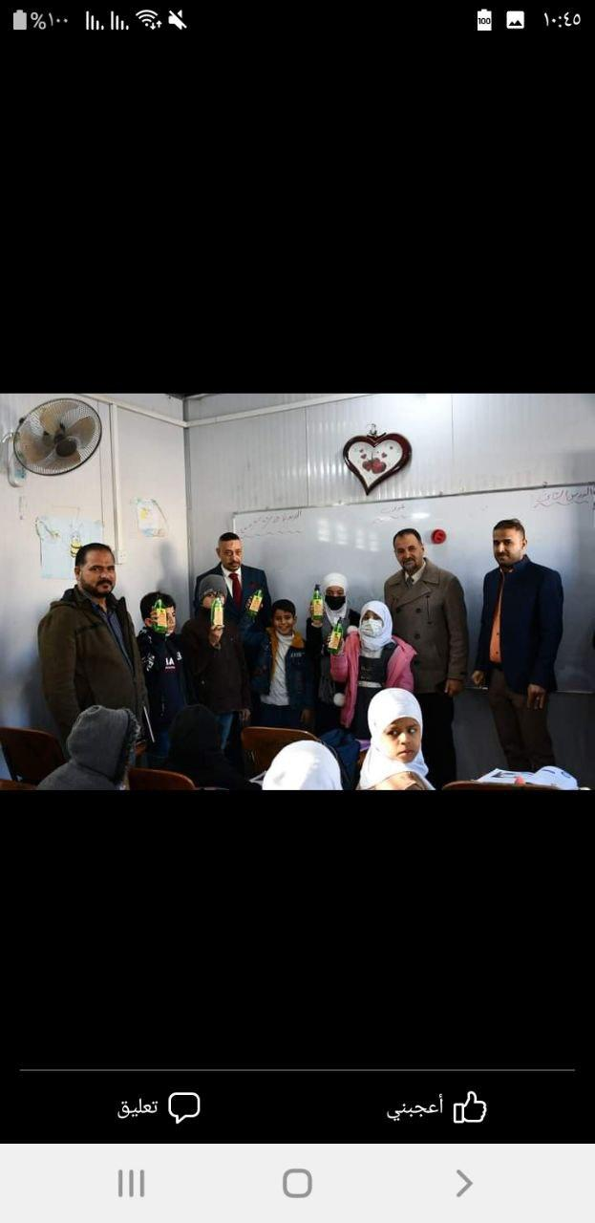 | 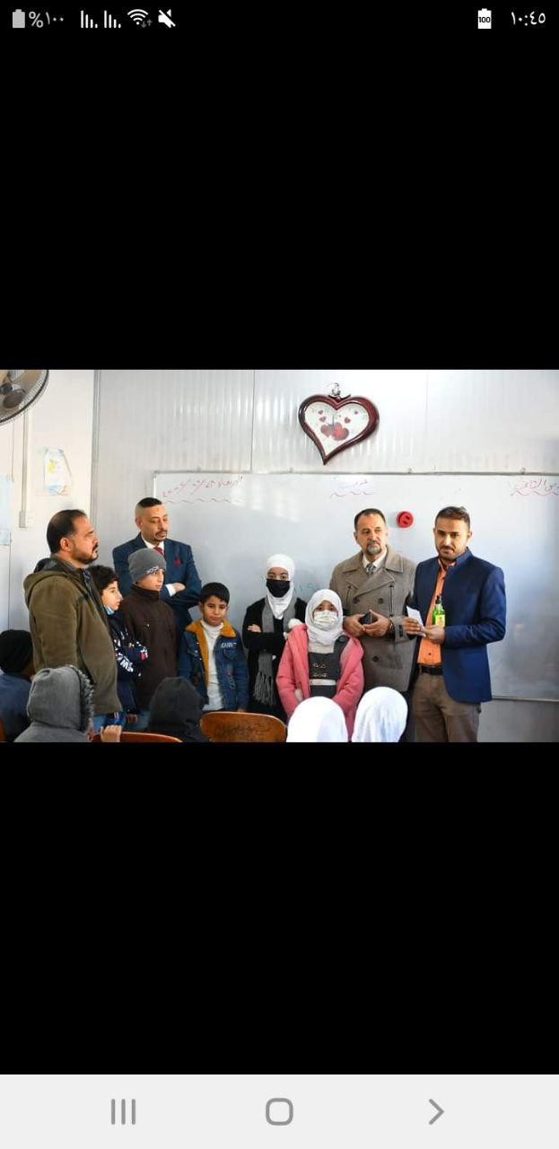 | 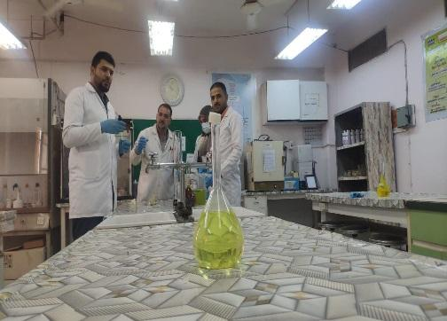
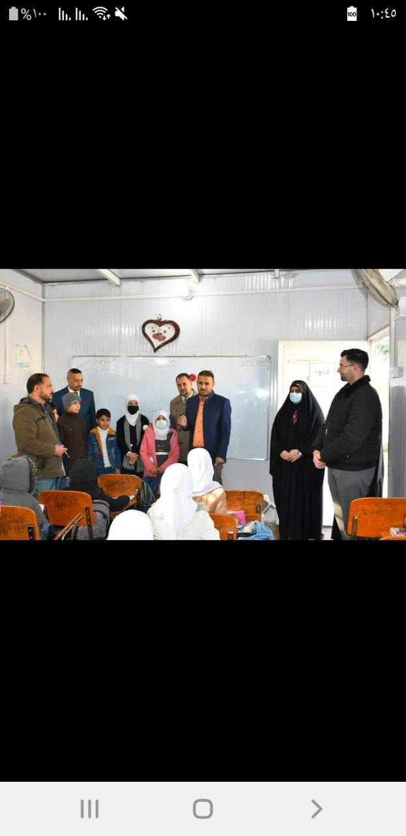 |  | 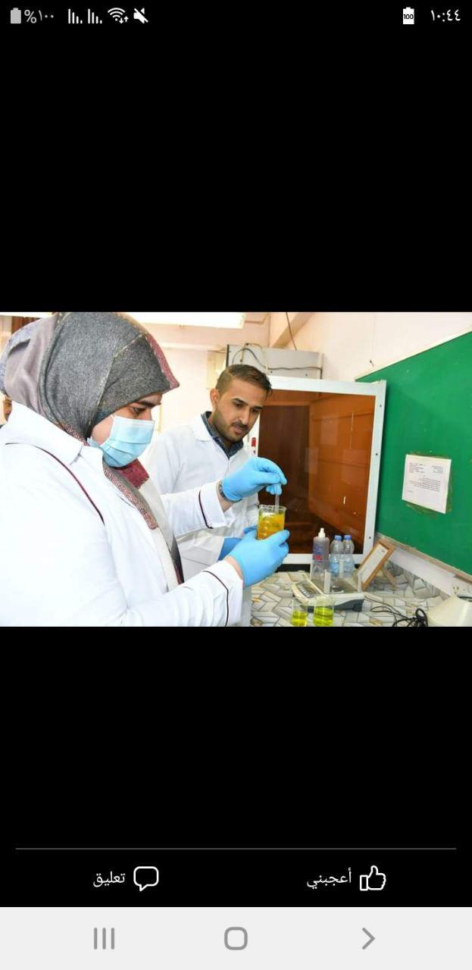

- The Women’s Empowerment Unit held a workshop entitled (How to deal with a woman in the event of foreign objects entering the child’s body)
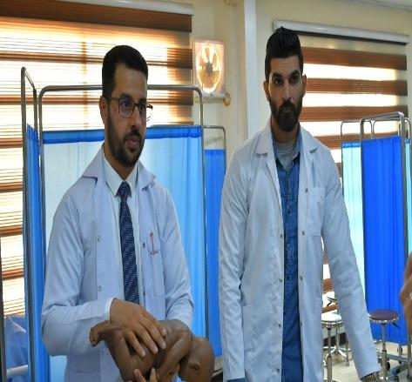 | 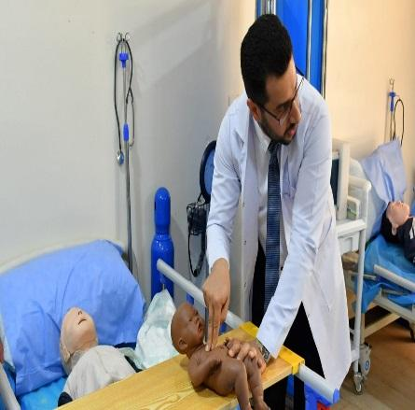
- Within the activities of the Sustainable Development Committee, the Medical Laboratory Technology Department organized a volunteer campaign that included carrying out several medical examinations ( CBC, G.U.E, G.S.E) for various groups of the university community, with a total of 40 people distributed among students, associates, and workers.
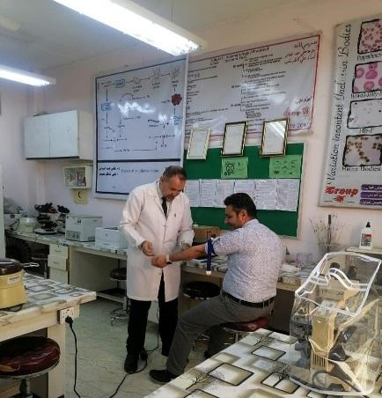 |  | 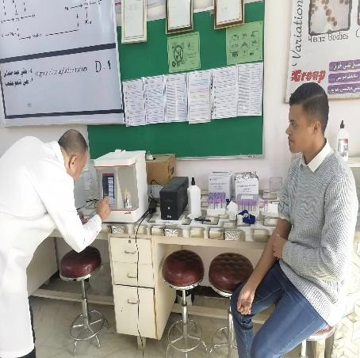

- Within the activities of the Sustainable Development Committee, which aims to serve the community, the Community Health Technologies Department organized a volunteer activity that included measuring blood pressure and other vital signs for members, students, and workers.
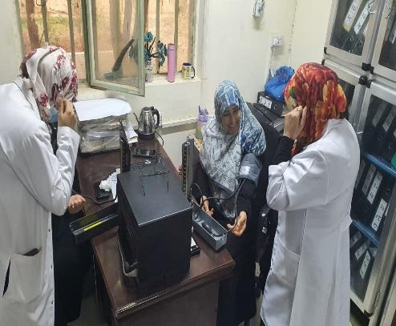 | 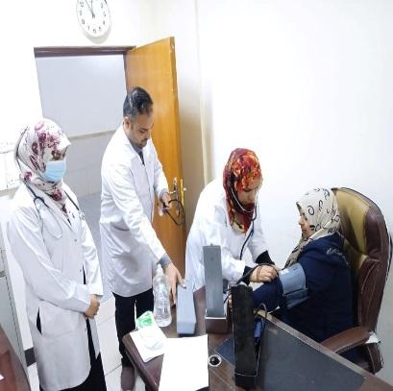 | 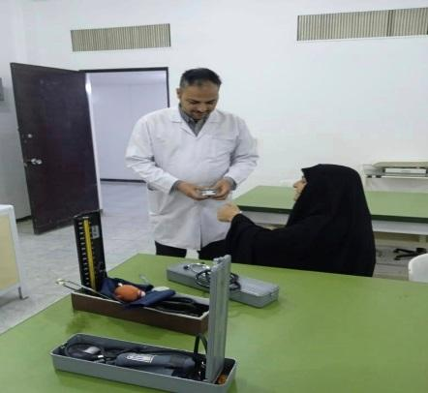

- In cooperation with the Sustainable Development Committee, the Limb and Support Manufacturing Technologies Department conducted a training course on the types of blood types, their inheritance and their importance in the human body.
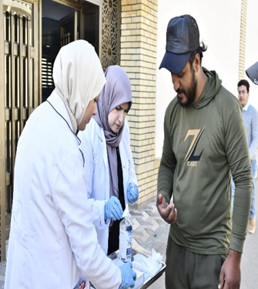 | 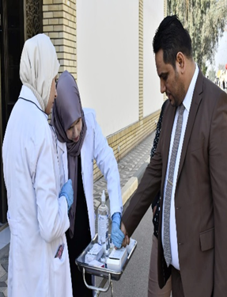

- In cooperation with the Commission for Sustainable Development, the Nursing Technology Department organized a training course on first aid for burns
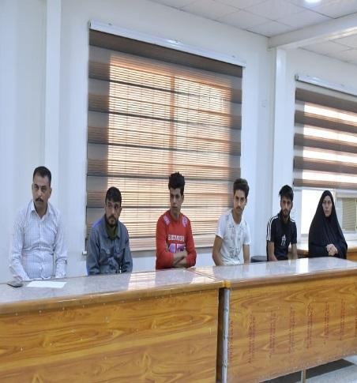 | 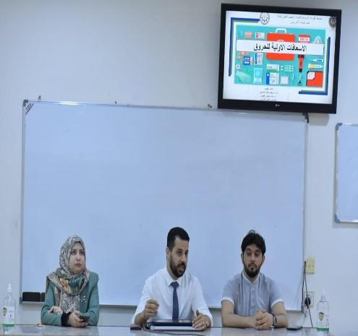

- The Women’s Empowerment Unit held a workshop entitled (The Role of Artificial Intelligence in Early Diagnosis of Breast Cancer)..
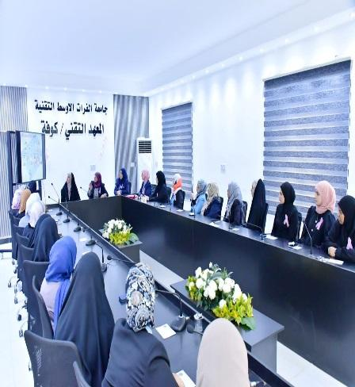 | 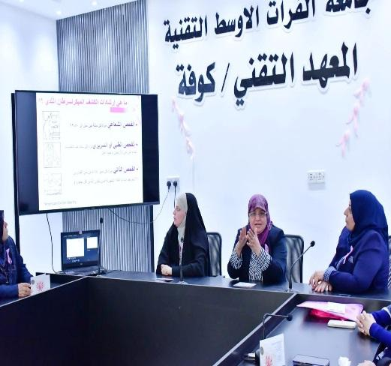 | 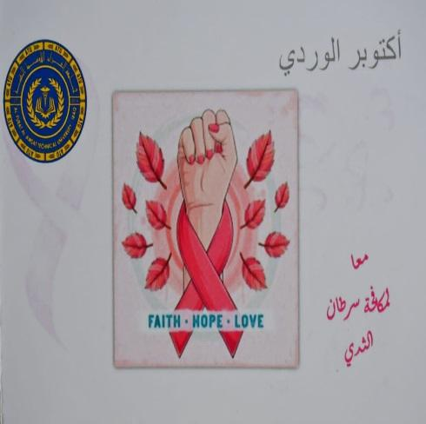

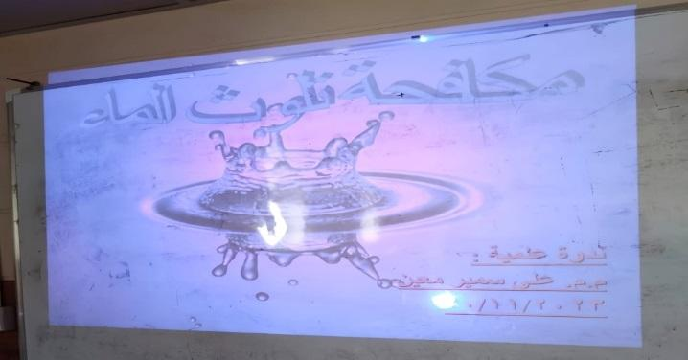
- In cooperation with the Commission on Sustainable Development, the Department of Plant Production Technologies organized a special scientific symposium on combating water pollution

- Holding a workshop entitled Designing a Solar Energy System for a Residential House by the Electrical Technologies Department
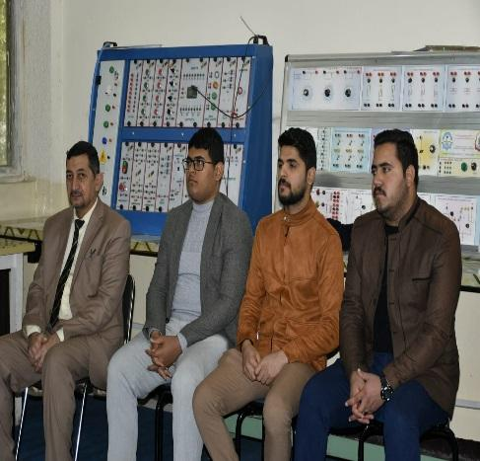 | 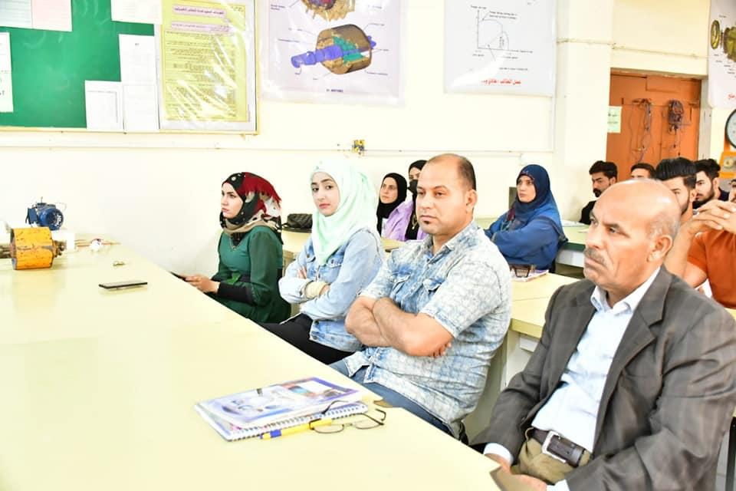 | 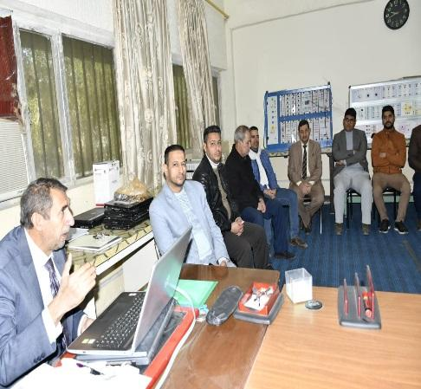

- Answer to the third point
- Rehabilitation and maintenance work was carried out on the infrastructure of the Medical Laboratory Technology Department building, amounting to 500 square metres. The work included repairing the damaged areas of the walls and floor of the building and its classrooms, painting the walls, maintaining electrical equipment and lighting, in addition to maintaining the laboratories.
- 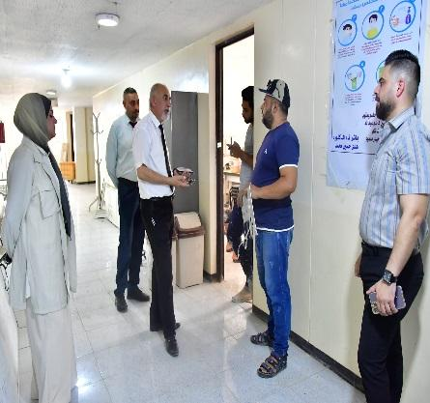 | - 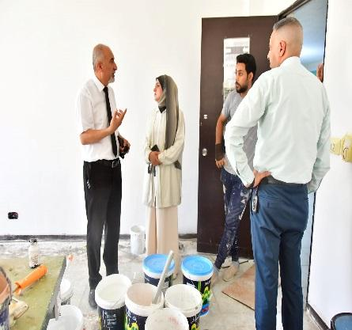 | - 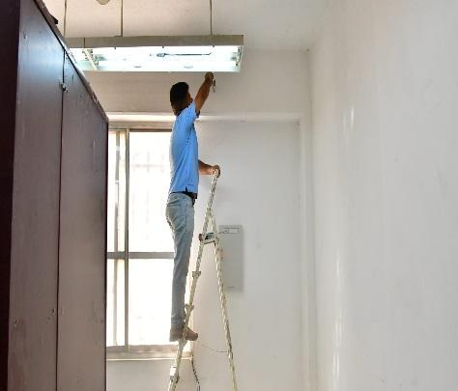

- Rehabilitation and maintenance of the infrastructure of the Technology Department building was carried out Community health And in reality 950 m²

- The construction of a model building for the Information Technology Department was carried out, which includes four modern computer laboratories with a capacity of 100 students for each laboratory. The laboratories are characterized by high-quality equipment, including computers and furniture, that meet the aspirations of high-level training. In addition, the building was equipped with an advanced studio for recording electronic lectures using light board technology. A number of administrative offices and service accessories were also provided to meet the needs of the institute’s workers.
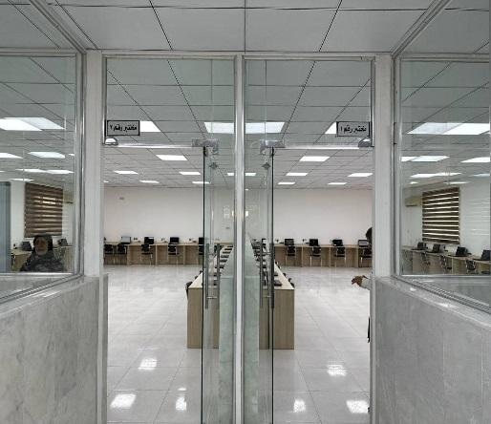 | 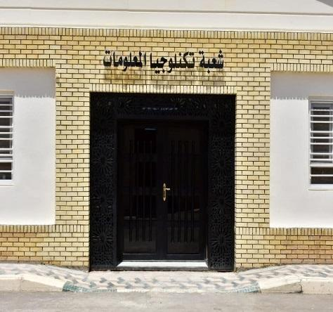 | 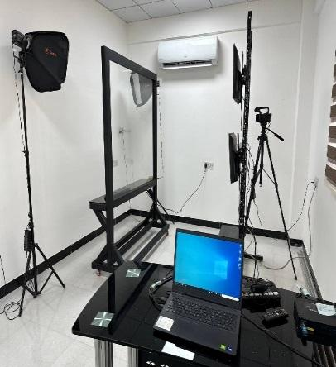

- The construction of a central conference hall that can accommodate 240 people was carried out. The hall is equipped with advanced sound systems, smart display screens, and laser data show technology. The best types of furniture have been provided to make it a model hall that accommodates conferences, scientific and cultural events, and the hall’s building area is (6*18) square metres.² With stage (15*18) m²
- 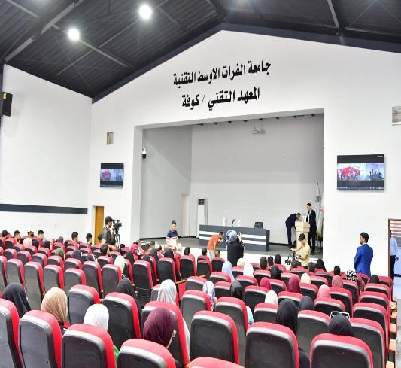 | - 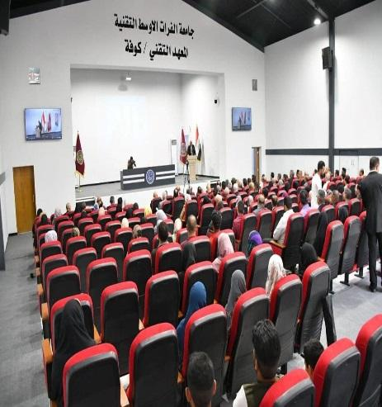 | - 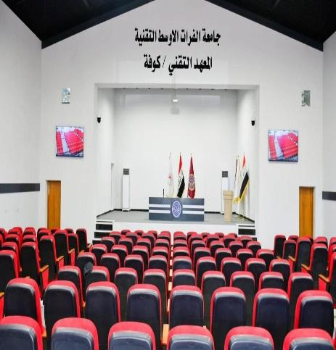

- Establishing a continuing education hall designated for holding training courses, which is equipped with an advanced smart screen and modern sound systems. This hall allows training courses to be presented in an interactive and innovative way, with an area of ​​(6*16) m2
- 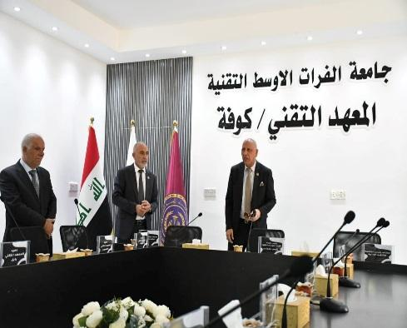 | - 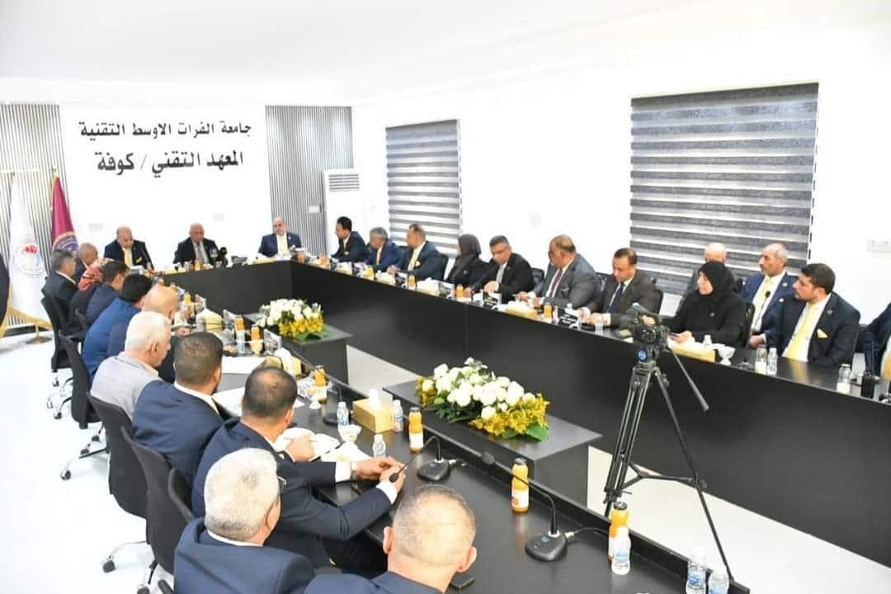 | - 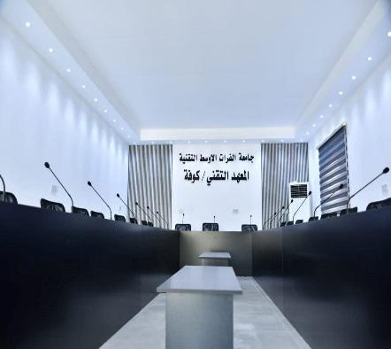

Student championship at the Najaf Technical Institute and the importance of such competitions in enhancing sportsmanship among students.
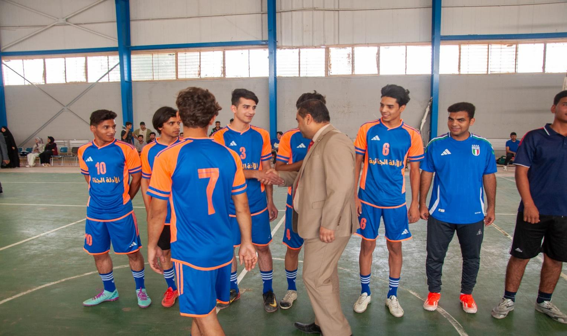
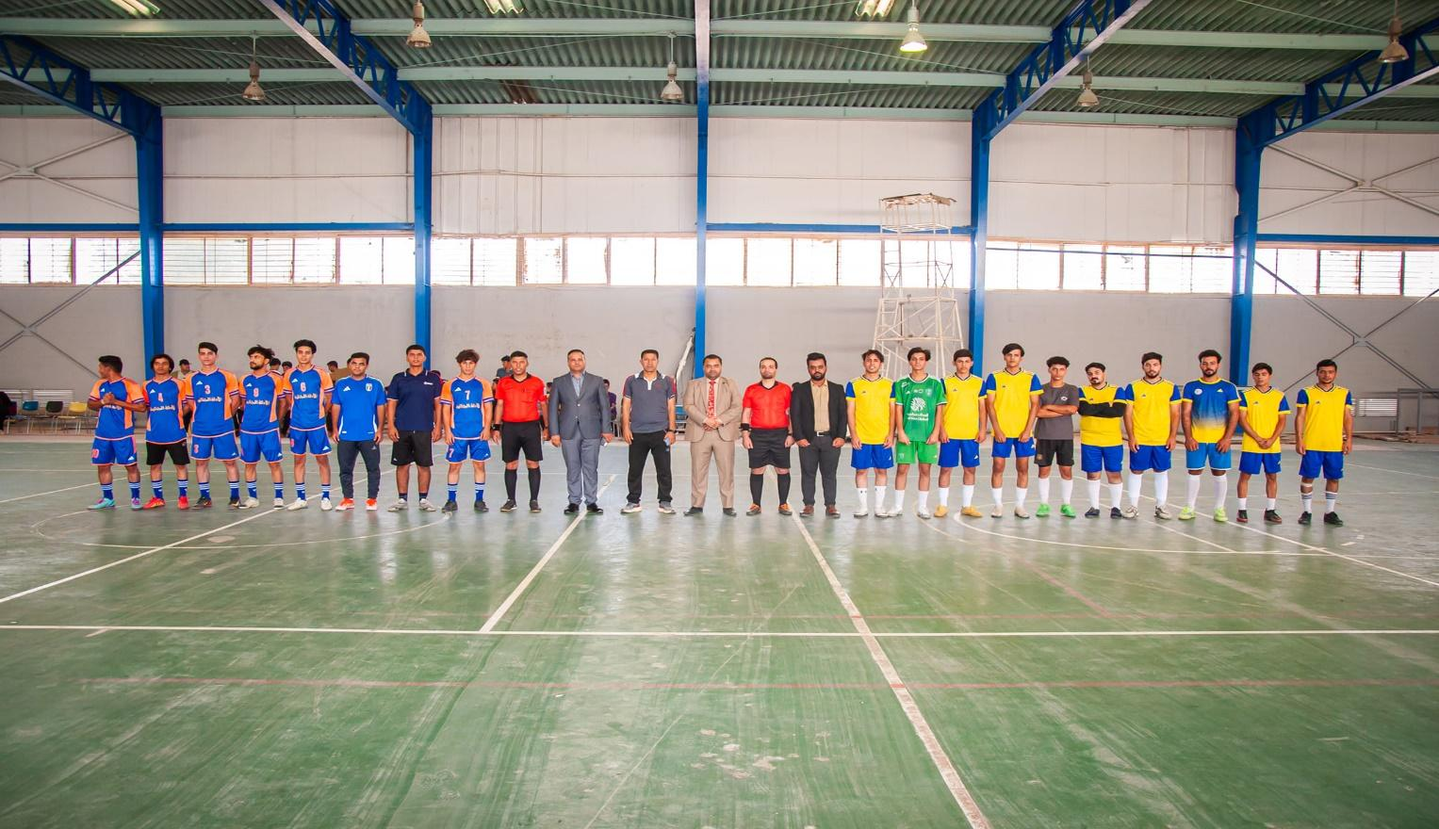

- Opening of the sports stadium on campus
The sports stadium includes eight courts for tennis, basketball, volleyball, badminton, and pentathlon, which were established on an area of (5,000) five thousand square meters, and a hall for the public with a capacity of 300 people.
On the other hand, the parks and green spaces were opened, the area of which the university has been increasing in the framework of achieving sustainable development goals. The added green spaces amounted to 10,000 ten thousand square meters, which included planting palm trees and other evergreen species, for which water is provided using modern irrigation systems.
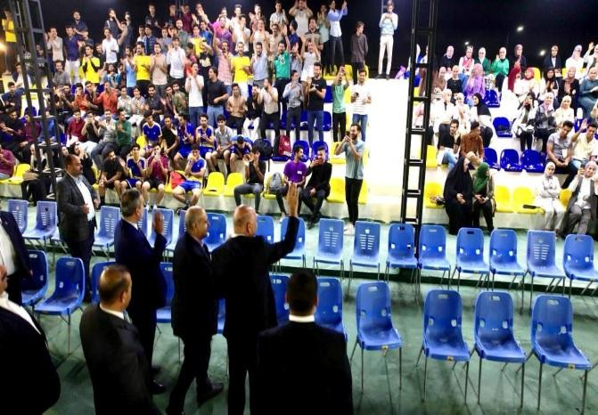
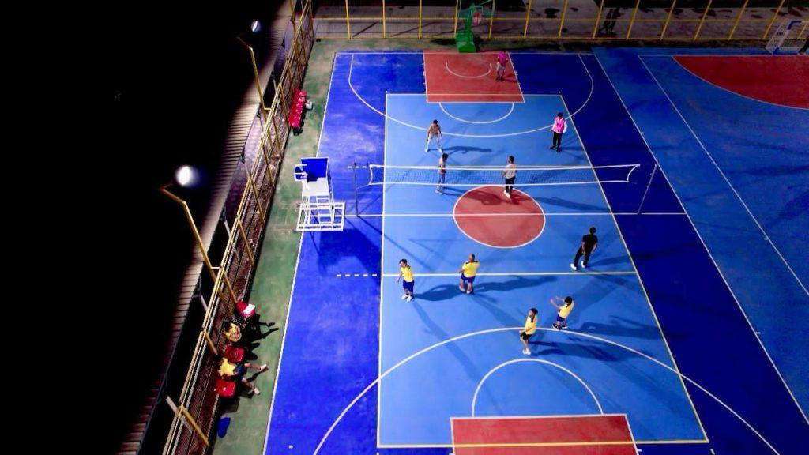

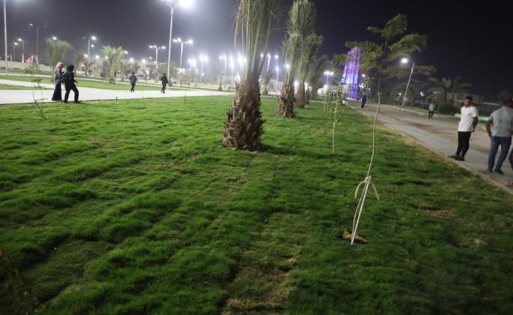
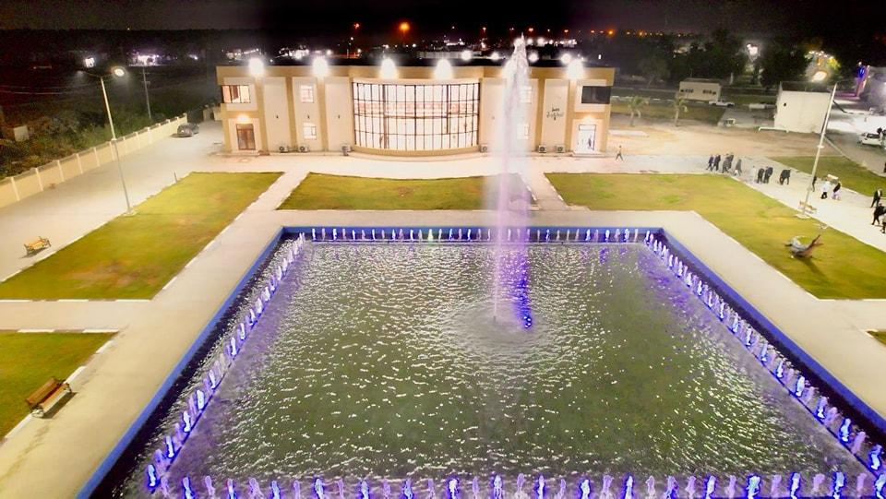



- Holding a university volleyball championship (male and female), as well as an Iraqi university table tennis championship
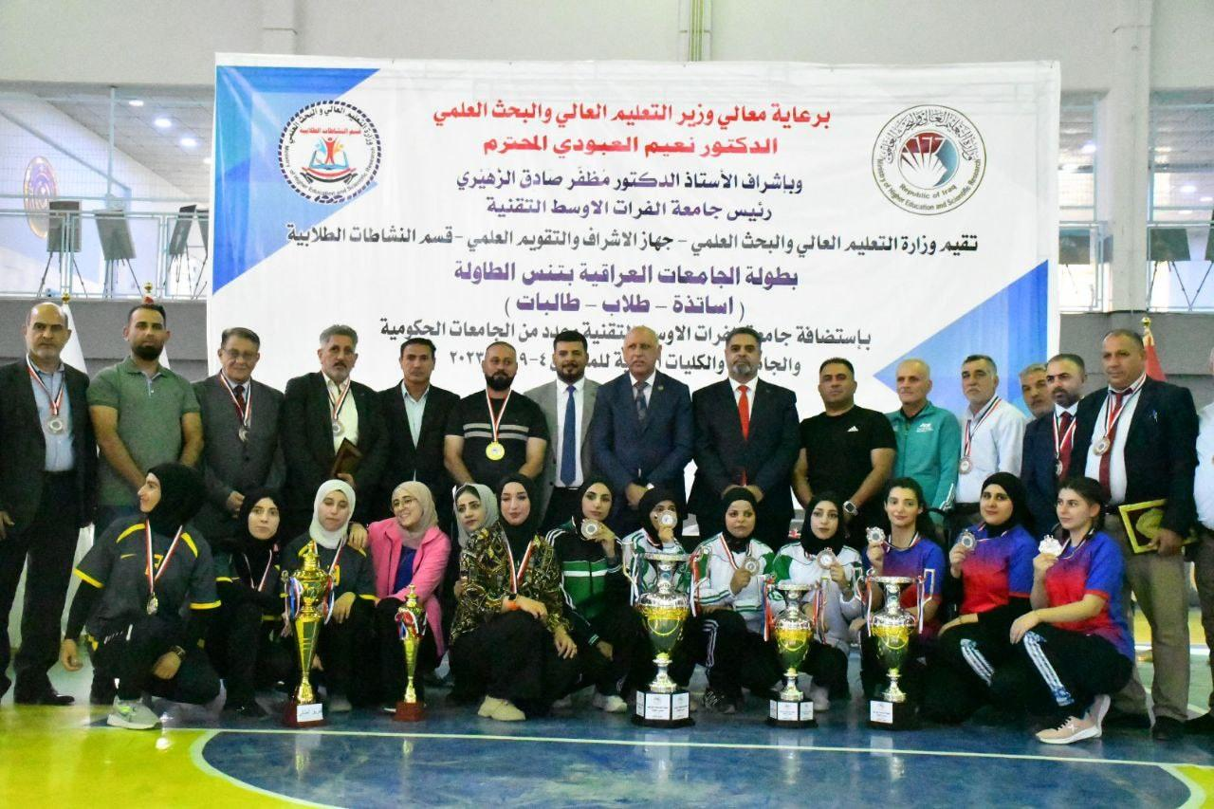
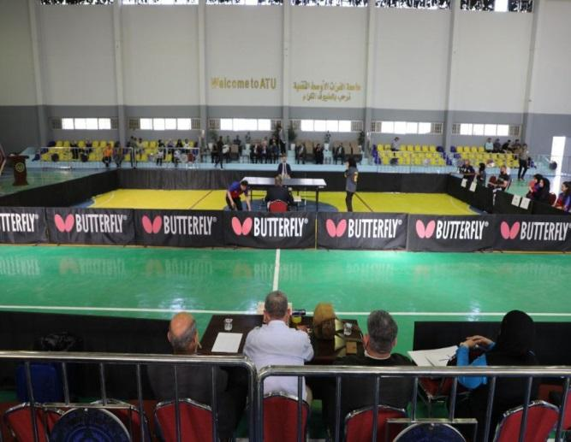
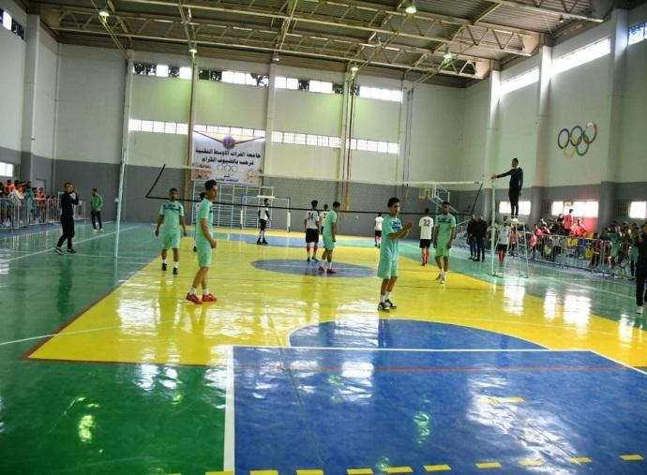

Medical staff from morning and evening studies:

They are graduates of pharmacy, nursing, community health, and medical laboratories, graduates of technical institutes and medical technical colleges, who are appointed centrally for distribution to the various health departments in the country to contribute from their work sites to achieving the third goal of the Sustainable Development Goals, “Good Health and Hygiene,” and the sixth goal, “Clean Water and Hygiene.” “By exercising their duties, they contribute to achieving all sustainable development goals, because providing health awareness to the community helps in this. The introduction of evening studies for medical departments helps to achieve the desire of students, and this achieves the eighth goal, “Decent work and economic growth,” one of the sustainable development goals set by the United Nations, through the presence of job opportunities on the basis of central appointment, and this contributes to creating many decent job opportunities, and in this way they contribute. In achieving economic growth.

Activities of the University to Support Public Health:

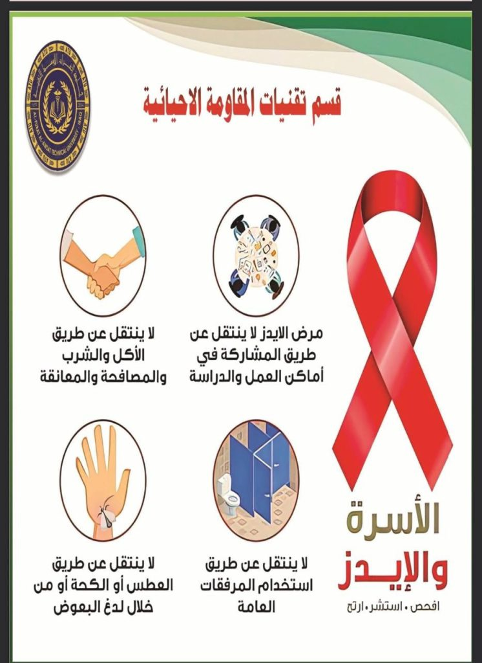
- On World AIDS Day, Al-Musayyib Technical College at Al-Furat Al-Awsat Technical University organizes an awareness campaign for its students: https://atu.edu.iq/?p=23106
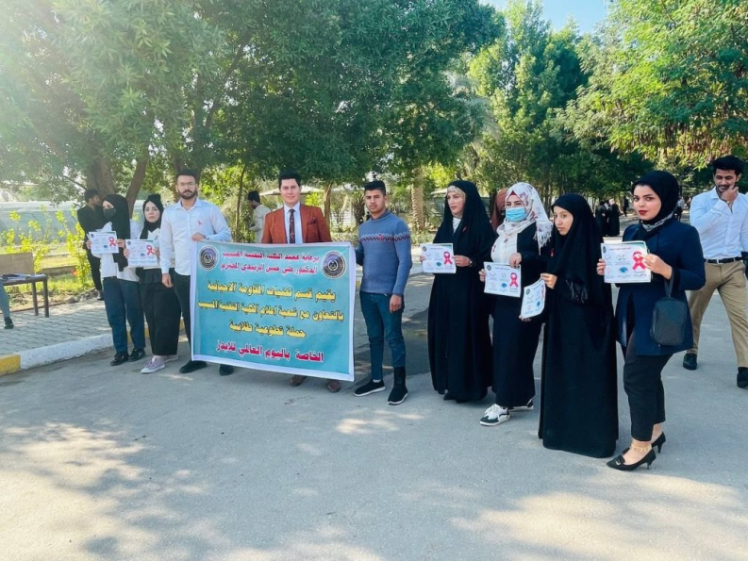

On the occasion of World AIDS Day and under the auspices of Dr. Ali Al-Zubaidi, Dean of the Musayyib Technical College, the Department of Bioresistance Technologies, in cooperation with the Media Division of the Musayyib Technical College at Al-Furat Al-Awsat Technical University, organized an awareness campaign for the college’s students to know the dangers of this disease and how to prevent it. The campaign aims to disseminate health and cultural guidance to our students about This disease and how to prevent it, and World AIDS Day or World AIDS Day is considered an annual global occasion that is commemorated on December 1 of each year. This occasion began to be commemorated annually as a result of a decision by the World Health Organization. The United Nations General Assembly stressed the importance of commemorating this occasion in its resolution 15/34. It is devoted to commemorating the occasion and raising awareness of the dangers of AIDS and the dangers of transmission of the HIV virus that causes it, through the use of tools. Contaminated sharps or other practices without taking appropriate prevention methods or through the use of contaminated medical equipment and tools. As well as ways to deal properly and correctly with those infected with the disease or carrying the virus that transmits it, as many of them suffer from discrimination and sometimes persecution because they are infected. AIDS is considered a dangerous disease, and its infection rates are still high, especially in developing countries.

- A delegation from Jaber Bin Hayyan University visits the College of Health and Medical Technologies, Kufa... to activate the memorandum of understanding concluded between the two sides: https://atu.edu.iq/?p=19221
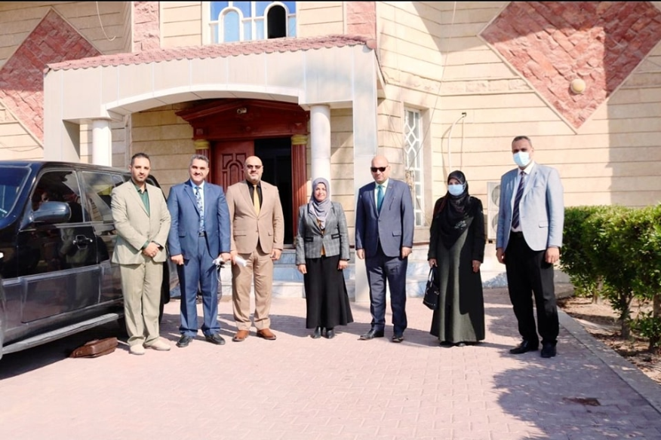

A delegation from Jaber Ibn Hayyan Medical University, headed by the Assistant President of the University for Scientific Affairs, Professor Dr. Hanan Dikan Abbas, visited the College of Health and Medical Technologies, Kufa, at Al-Furat Al-Awsat Technical University. The Scientific Assistant to the University President, Professor Dr. Ahmed Ghanem Waday, who accompanied the delegation to the college, said that this was in harmony with the university’s policy of activating the provisions of the memorandum of understanding concluded between public universities in health and medical specializations for the purpose of developing universities in a way that achieves their advancement at the Arab and international levels.

For her part, the Dean of the College, Professor Dr. Angham Jassim Al-Ramahi, received the delegation, which consisted of the Assistant Dean of the College of Medicine for Scientific Affairs, Assistant Professor Dr. Ali Najeh Al-Awadi, and the Assistant Dean of the College of Pharmacy for Scientific Affairs, Dr. Fadel Abbas Al-Zayadi. During the meeting, Al-Ramahi stated that the visit aims to activate scientific and cultural programs, including holding seminars, workshops and joint scientific conferences, as well as cooperation in research fields in a way that contributes to achieving academic goals.

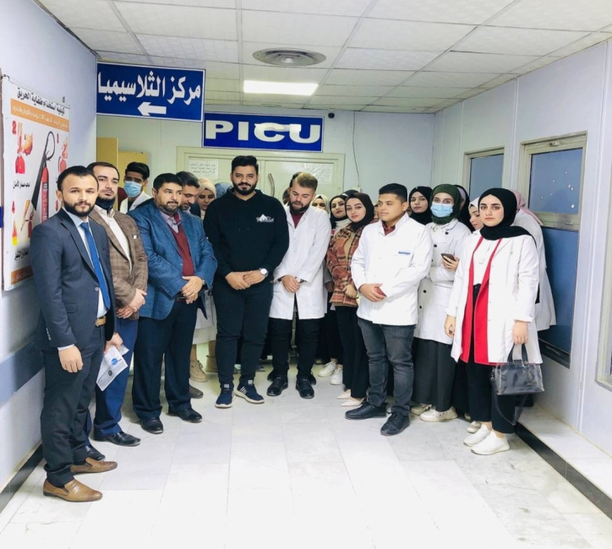
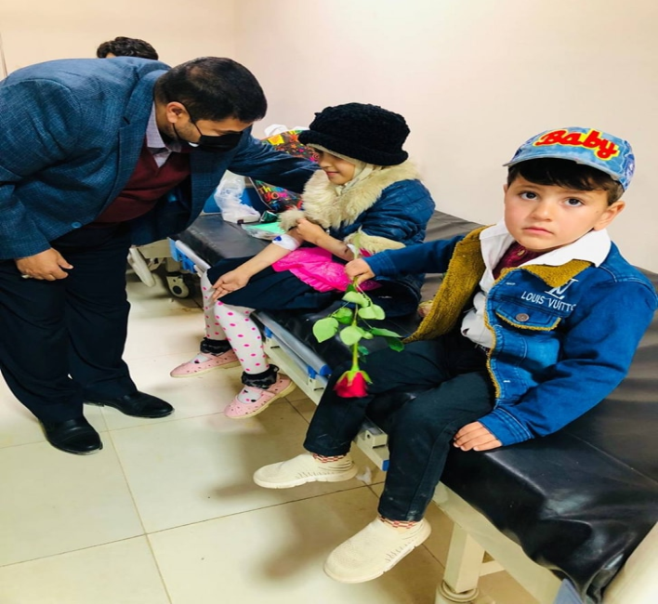
- Al-Furat Al-Awsat Technical University visited the Thalassemia Center : https://atu.edu.iq/?p=19602

As part of a series of volunteer programs and activities that serve the community, a number of professors and students of the fourth stage of the Medical Laboratories Department at the College of Health and Medical Technologies, Kufa, at Al-Furat Al-Awsat Technical University, visited the Thalassemia Disease Center at Al-Zahra (AS) Teaching Hospital in Najaf. Department Head, Assistant Professor Dr. Raad Al-Jourani, for his part, explained that the visit aims to provide voluntary services to bedridden patients, identify their needs, alleviate their suffering, and instill a spirit of hope in their souls. At the conclusion of the visit, the professors and students extended their sincere thanks to the medical, nursing and administrative staff at the center and honored them for their efforts in serving patients, then distributed in-kind gifts to the deceased patients.

- Al-Furat Al-Awsat Technical University holds a symposium entitled Mechanisms for strengthening psychological immunity and stimulating positive thoughts: https://atu.edu.iq/?p=23112
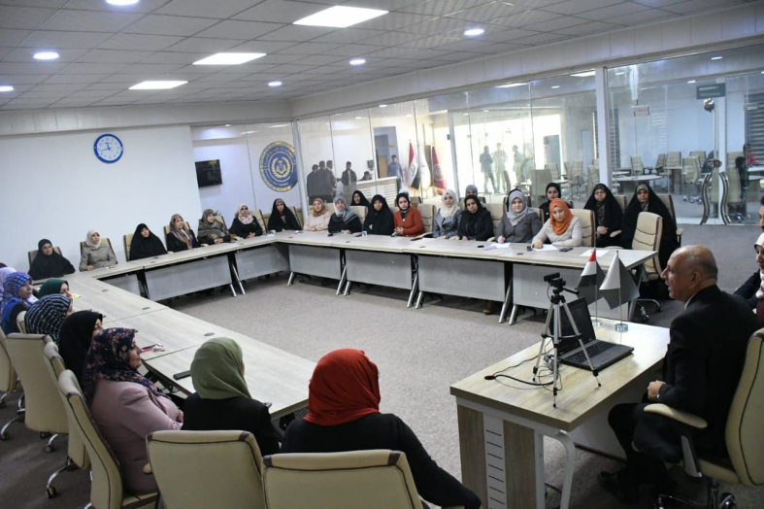
In the presence of the President of Al-Furat Al-Awsat Technical University, the Women’s Empowerment Unit at the University’s Presidency, in cooperation with the Center for Continuing Education, held a symposium entitled Mechanisms for Strengthening Psychological Immunity and Stimulating Positive Thoughts within the (Resilience Program) for the University’s Female Affiliates and Formations at the Kufa Site. The President of the University in his speech. At the start of the symposium and his attendance as part of it, he pointed out the importance of empowering women in a way that enhances their capabilities scientifically and culturally to be an effective element in achieving sustainable development and community service. The symposium included a lecture by the Lebanese development expert, Mrs. Rania Farouk, which was hosted remotely via Zoom technology, in which she discussed how Psychological protection for women, treatment of psychological pain, and not pretending to be relieved, as well as introducing the concept of psychological immunity and skill in acquiring greater capabilities of flexibility, as well as self-protection, modifying and protecting thinking, as well as identifying strengths and weaknesses, diagnosing, monitoring negative thoughts, and increasing positive energy by talking to oneself.

- The Laboratory Research Fields Follow-up Committee at Al-Furat Al-Awsat Technical University follows up the stages of postgraduate students’ research: https://atu.edu.iq/?p=19297
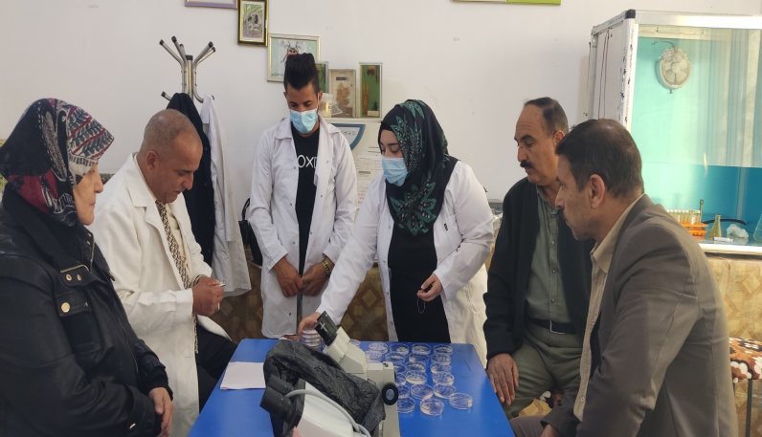
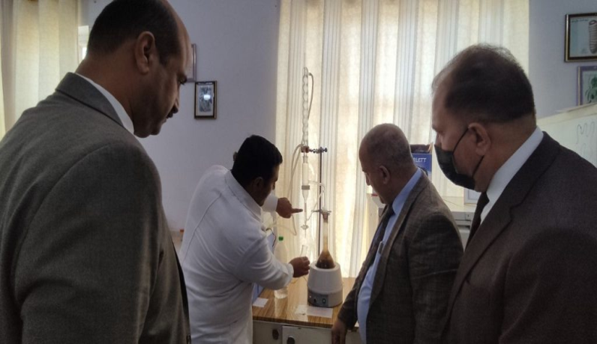

The Laboratory Research Fields Committee at Al-Musayyib Technical College, Department of Bioresistance Technologies, Al-Furat Al-Awsat Technical University, followed the research laboratory for postgraduate students and reviewed the students’ experiences. The committee expressed its observations and directions if the committee reviewed the research stages of master’s students

- A new building for the Pharmacy Technology Department at the Kufa Technical Institute , the Department of Health Management Technologies at the Rumaitha Technical Institute and the Ibn al-Haytham Model Hall:https://atu.edu.iq/?p=23022 . https://atu.edu.iq/?p=20266

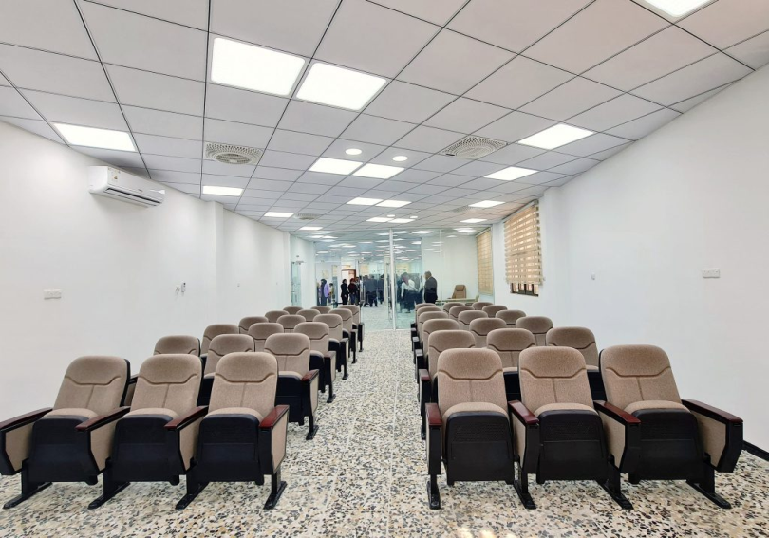
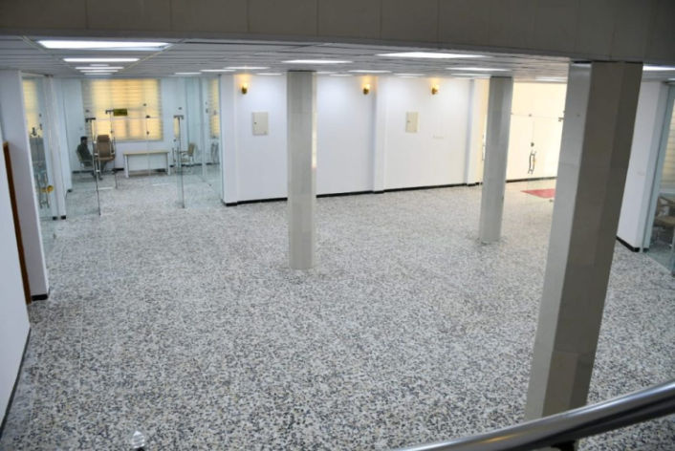

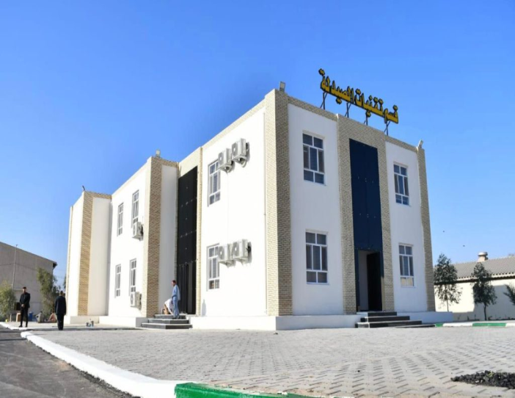
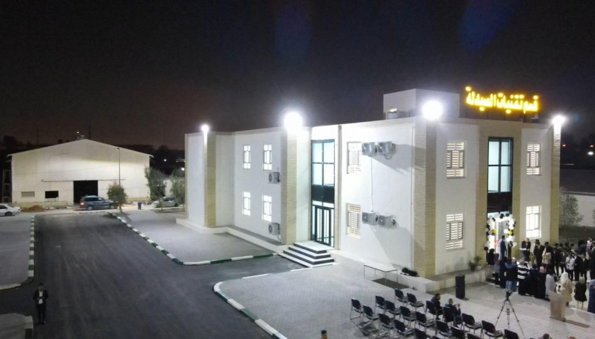
The new building includes (8) eight model laboratories for students equipped with high-tech equipment, in addition to two model pharmacies, each with a capacity of (50) for fifty students, providing practical and training services to students at a high level in a way that serves the educational process for dear students. The new building also includes an administrative wing. It consists of (7) seven rooms for the department head and associates. Meanwhile, the Ibn Al-Haytham model hall for theoretical teaching was opened, which accommodates (160) one hundred and sixty students, equipped with the latest education and teaching requirements. This is a major scientific achievement that contributes to providing scientific services to the people of Muthanna Governorate in the field of hospital and health center management.

- Al-Furat Al-Awsat Technical University organizes a workshop to present and discuss Iraqi standards for laboratory quality: https://atu.edu.iq/?p=22629
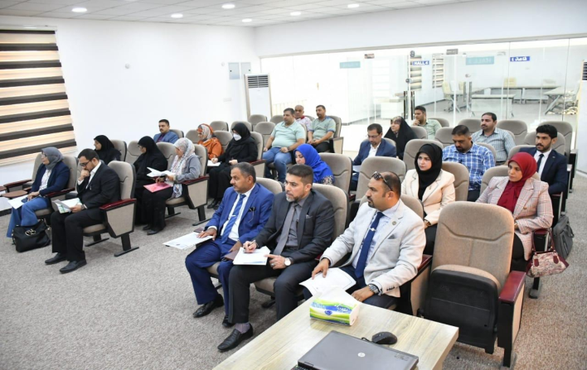
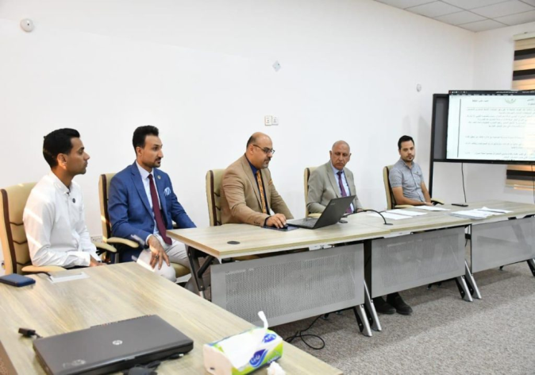

-In a promising humanitarian initiative that embodies the university’s concept of serving society... The President of Al-Furat Al-Awsat Technical University supervised the gifting of a number of people with disabilities and special needs with artificial limbs that were manufactured by students and with their own capabilities in the workshops of the Limb and Support Manufacturing Technologies Department in Kufa Technical Institute, in the presence of the Assistant President of the University for Scientific Affairs, Professor Dr. Ahmed Ghanem, the Dean of the Institute, Professor Dr. Fadel Sami Zaghir, the Chairman of the Limb and Support Industry Committee in the Ministry of Health, Professor Raad Hashem, Dr. Mufid Azhar Abu Ghoneim, representative of the Najaf Health Department, and a number of associates and students in the aforementioned department.
-Al-Zuhairi in his speech: The university presidency adopted the creation of this promising specialization at the Kufa Institute to contribute to the preparation of promising technical cadres with a high level of skill who have the ability to qualify this category of society, and for the university to be a center of scientific and humanitarian radiation for society and to provide a technical educational environment that stimulates education and creativity and contributes to Preparing highly qualified graduates as well as achieving partnerships with sectors of society and private and mixed sector institutions related to scientific and humanitarian activities and providing services and consultations to solve labor market problems and develop its programs.
It should be noted that the Department of Limb and Support Manufacturing Technologies was created in the academic year 2018-2019 to meet
The requirements of this important and broad segment, especially in light of the scourges of war and terrorism that the country has suffered from for long periods, resulting in a large number of people with disabilities.

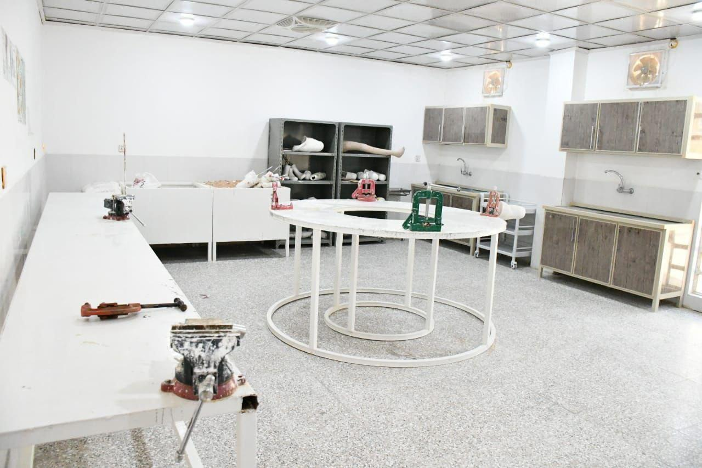
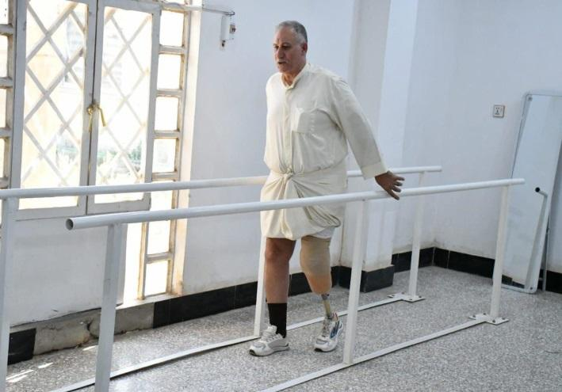
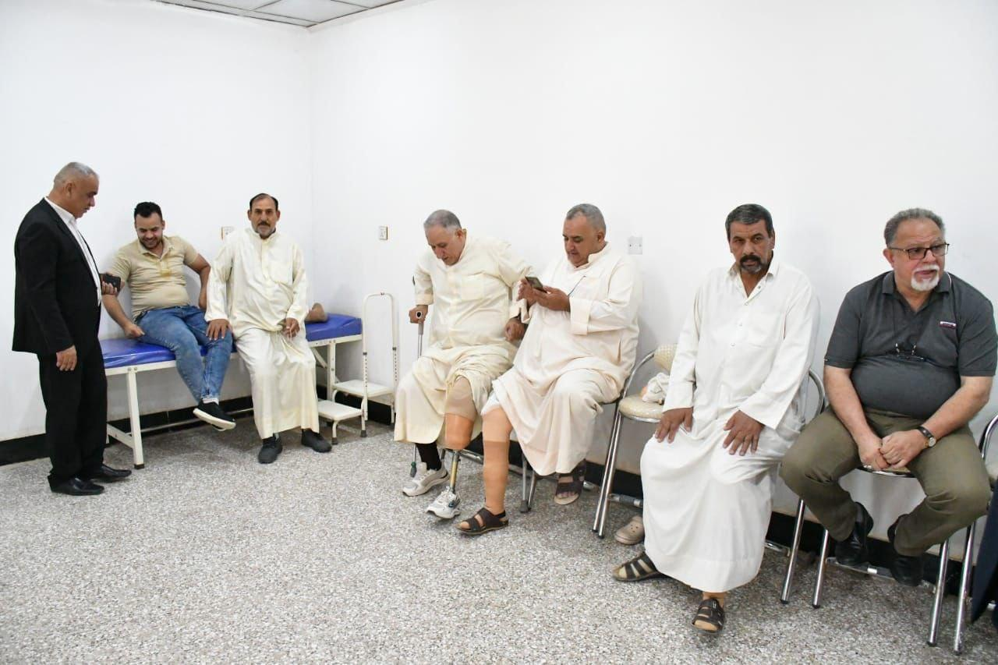
- Moreover, the health graduates of the Medical and Technical College in Kufa and the departments of the technical institutes of community health, nursing, medical laboratories, and pharmacy and these staffs are appointed centrally to enter into the health work immediately after graduation to contribute to the provision of health services to members of the community in a way that enhances the public health of citizens and reduces health problems and their treatment on the other hand, and the graduate's access to an economic resource that helps him to live in luxury with what he receives salary and allowances, and thus the university contributes to achieving the third goal "Good health and well-being" from Sustainable Development Goals.
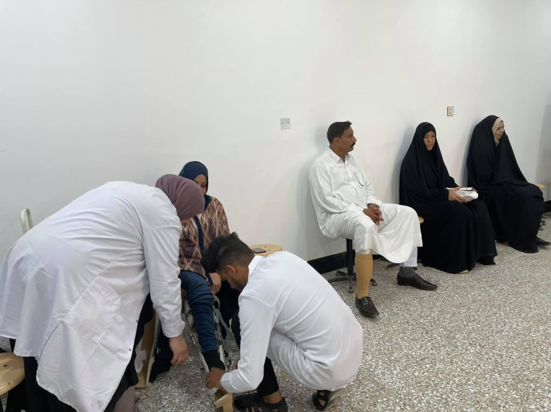

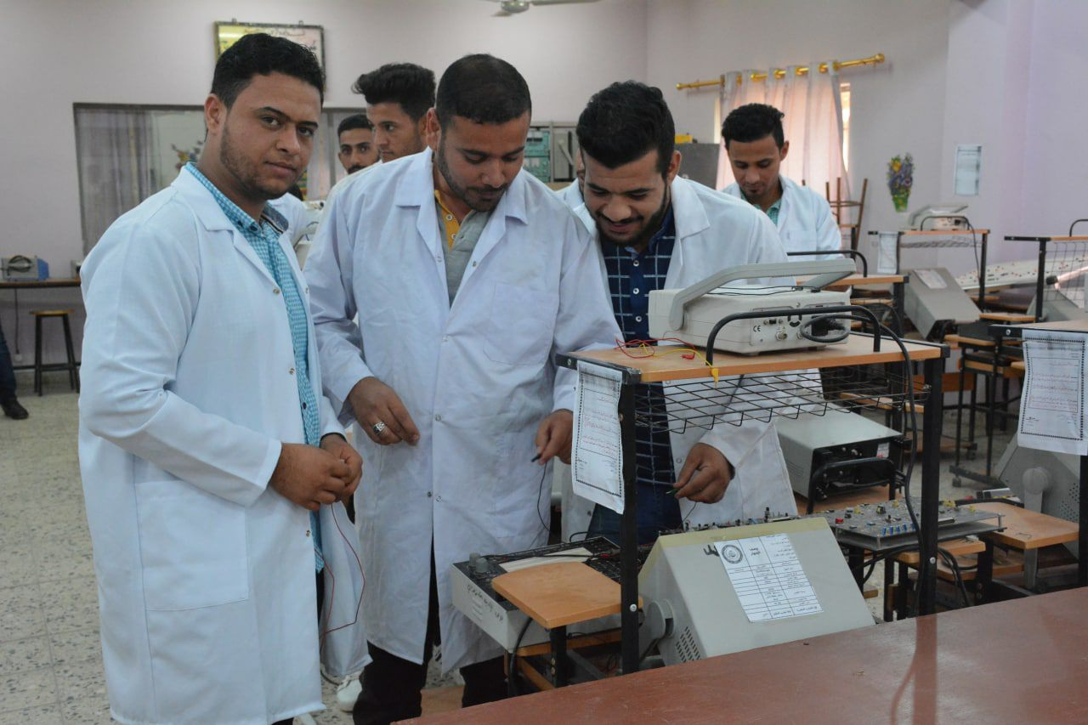

- The University Presidency has the Educational Guidance Division and it has grandmothers in all its sites headed by people with expertise and specialization whose mission is to help students who suffer from psychological and social problems to overcome them or send them to specialized medical centers and follow up their cases. As well as carrying out workshops, seminars and courses on topics related to the psychological and mental state by the university’s specialized cadres or seeking the assistance of those with medical specialties from outside the university.The unit also provides staff and students with free mental health support.

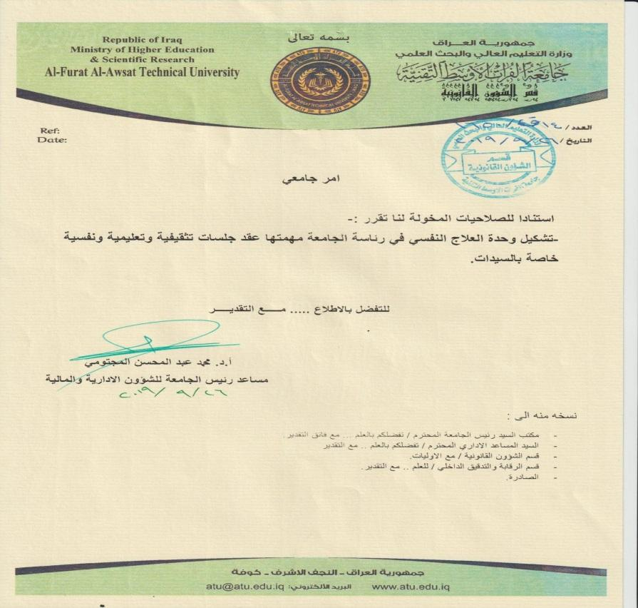

ATU university's official statement for establishing the physiologist unit (Al-Furat Al-Awsat Technical University, Iraq)
- Portable clinics for the public
Services are provided by students and supervised by doctors who are experts in medical care. Most of these services are provided during large events, such as festivals, gatherings, and religious ceremonies.

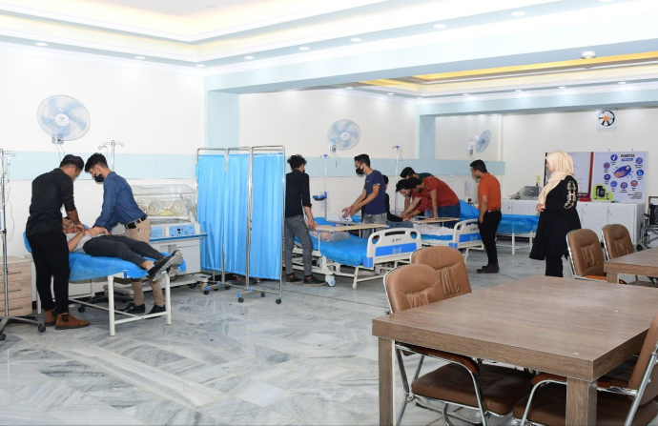
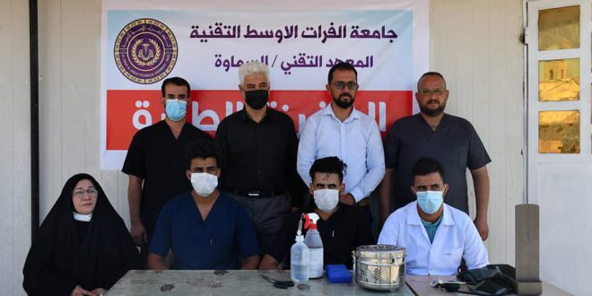

Volunteer at the Healthy Clinic (Al-Furat Al-Awsat Technical University, Iraq) to provide free public services

- Online clinic services
Visitors to the website have access to the services 24 hours a day, 7 days a week for free. All services are supervised by university experts on each campus. To reach the local community, all contact details are provided in Arabic.

Direct link to access
https://isa.atu.edu.iq/?page_id=2722

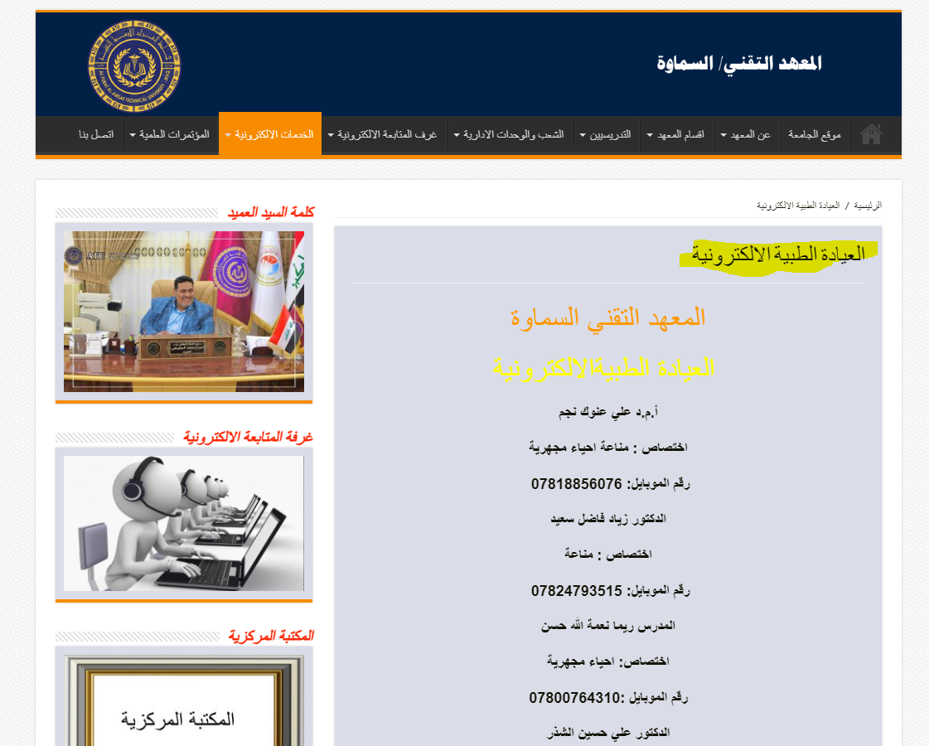
Online clinic services in Al-furat Al-Awsat university’s website

- Under the direct guidance of His Excellency the Minister of Higher Education and Scientific Research or the supervision of the President of the Al-Furat Al-Awsat Technical University, the university established its electronic advisory clinics in Najaf, Samawah and Babil and a self-examination for the possibility of contact with the new Corona virus (Covid19) due to the imposition of a curfew and the announcement of the state of ban In view of the exceptional circumstances that the world is going through in general and our country in particular due to the outbreak of the Corona virus epidemic, which has made it difficult for the patient to reach health institutions or private clinics for doctors.
- For their part, the professors in the university formations with medical specialties for the site of Najaf, Samawah and Babel represented by the College of Health and Medical Technologies in Kufa and technical institutes in Kufa, Najaf, Samawa, Babil and Musayyab formed consulting clinics and provide medical advice by sending inquiries to the private mail of the university page, which was established in the name of ( Electronic Consultation Clinic / Al-Furat Al-Awsat Technical University) and through an information form designed for the aforementioned purpose.
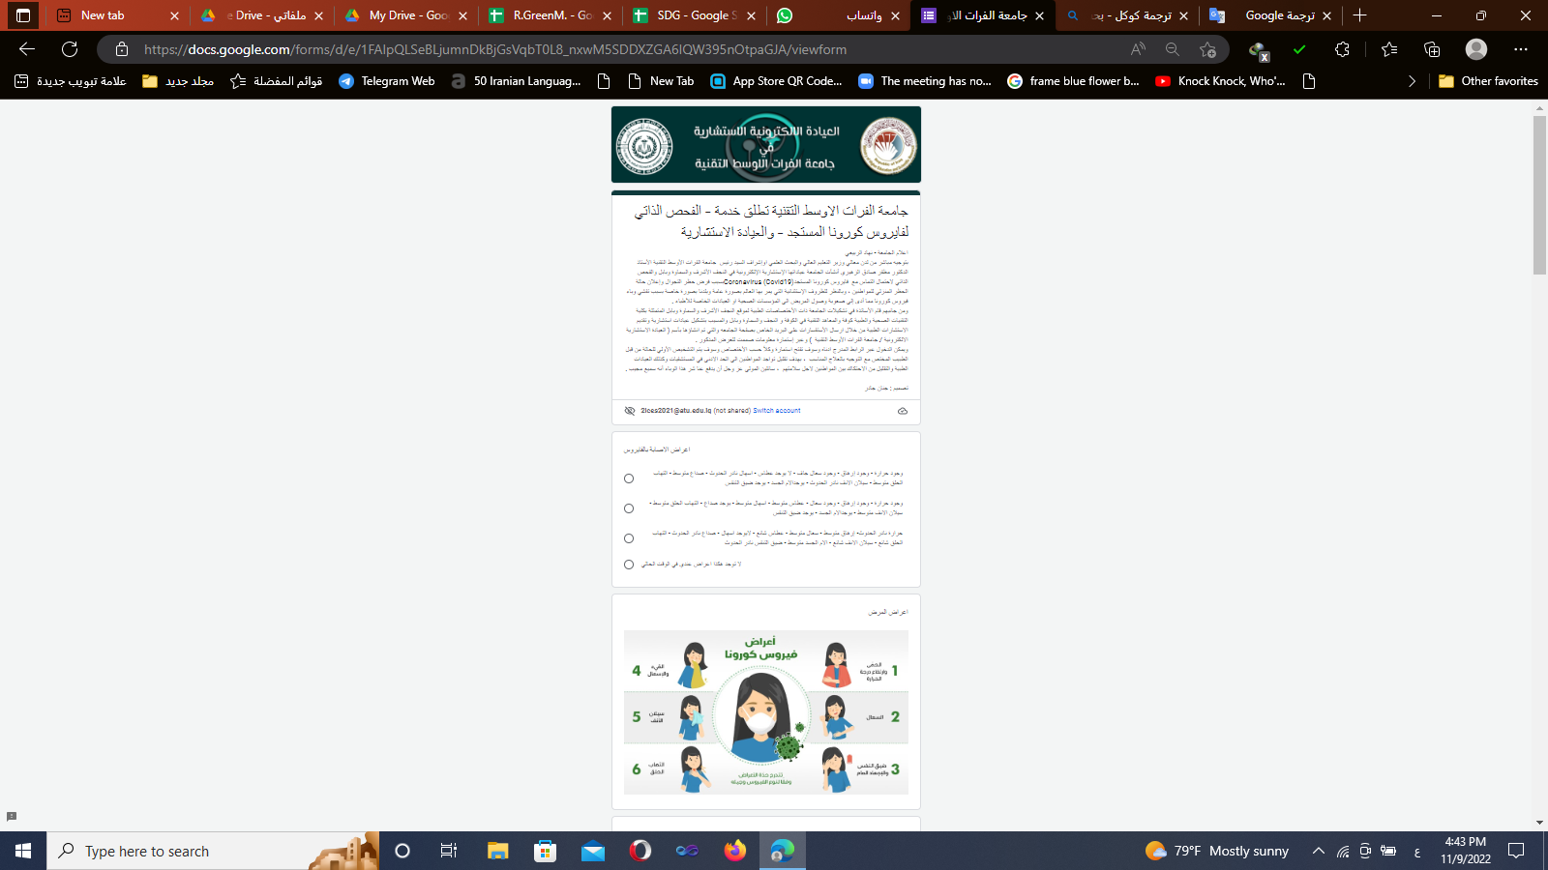
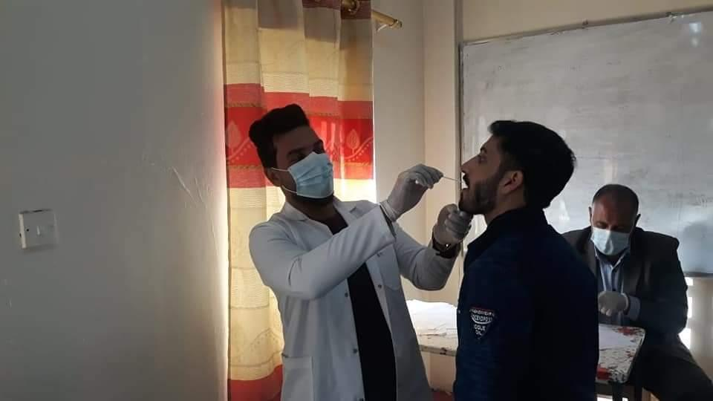
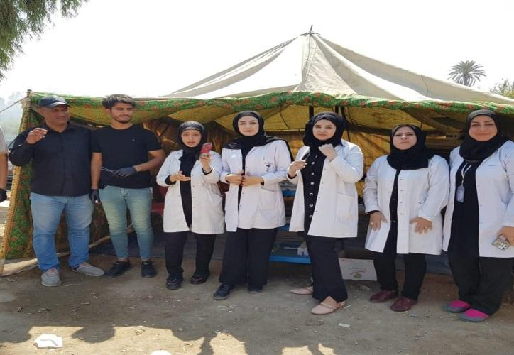
- It is possible to enter via the link listed below, and a form will be opened according to the specialization, and the initial diagnosis of the case will be made by the competent doctor with guidance on the appropriate treatment, with the aim of reducing the presence of citizens to a minimum in hospitals as well as medical clinics and reducing friction between citizens for their safety https://atu.edu.iq/?page_id=13882

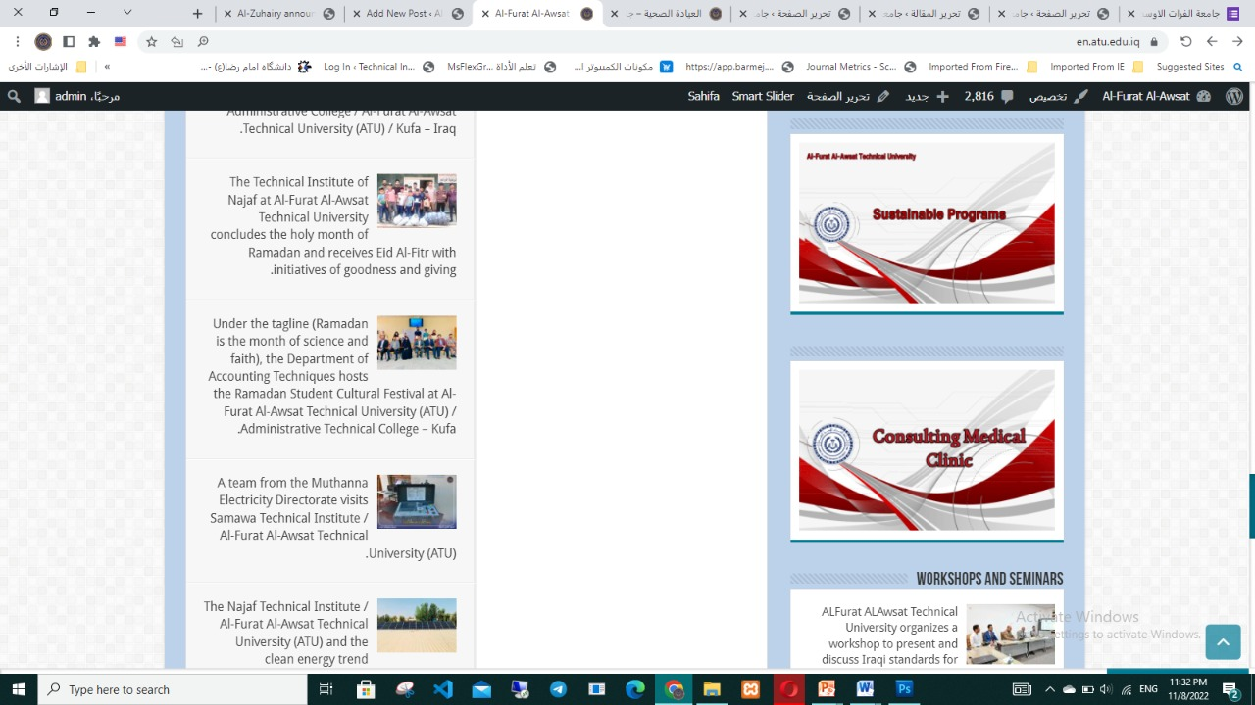

Free access of Healthy Clinic for staffs, students and community (Al-Furat Al-Awsat Technical University, Iraq)

ATU Provides different Access to sexual and reproductive health-care services including information and education services through:

- ATU faculty of medical sciences runs a short course for sexual and reproductive health – care. The course is run once per semester, and it is free of charge.
- Note that enrollment is not compulsory, and it's welcome for all students and staff, and members of the general public. The university also established the physiologist unit, which runs special educational workshops and seminars to women staff and students to help them overcome physiological issues due to workplace or home, as shown in the official university statement.
- In each of the university’s site, there is a health center that provides health services for students and members of the formation free of charge and follows up on all cases for the students who visit it to treat them to guide them healthily and provide them with appropriate information about epidemics, diseases and health care through indicative courses and posters to transfer them to their families and the general members of society.

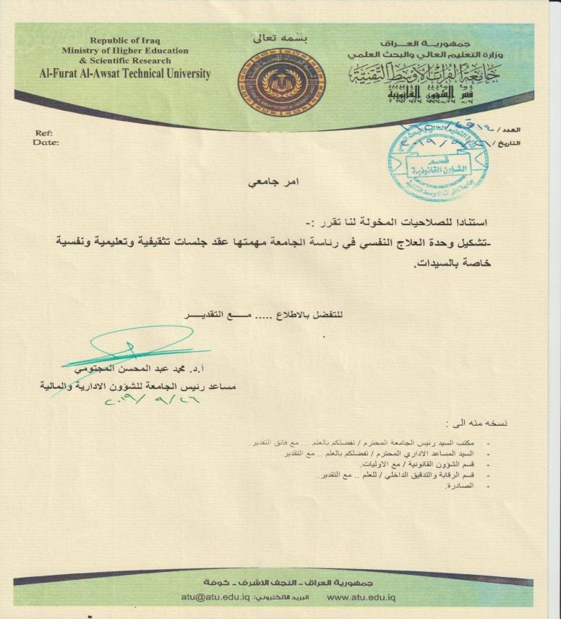
Establishment of the Psychotherapy Unit, whose task is to make awareness programs in mental and psychosexual health for all residents of the university
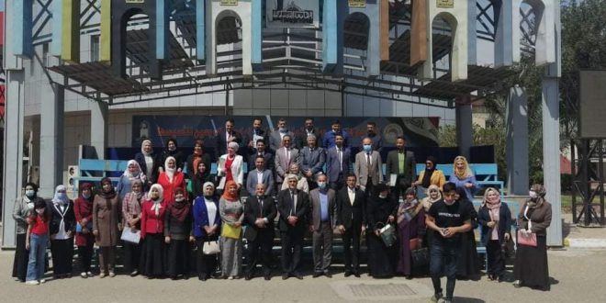
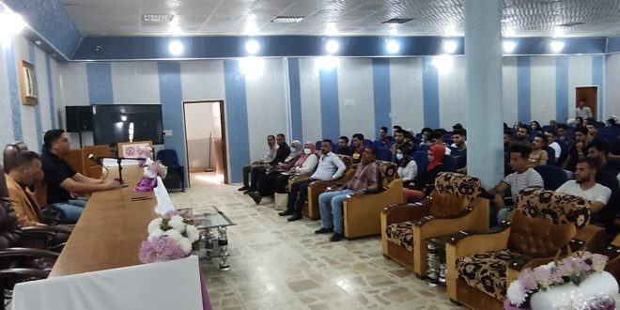

ATU university free sexual and reproductive healthcare courses for students (Al-Furat Al-Awsat Technical University,Iraq)

- It periodically gave Student guidance seminars & courses to students & staff in all sites through the Educational Guidance and Psychological Guidance Unit in each site of the university. In addition Organizing awareness campaigns on mental and psychological health
- Aims of the Educational Guidance and Psychological Guidance Unit
- Develop an annual guidance plan that extends throughout the academic year commensurate with the needs of students in this field.
- Work on the implementation of the guiding plan and evaluate it annually.
- Carry out the process of individual and collective guidance for students in order to provide assistance and solve the problems facing them.
- Carry out the process of group orientation in classes to discuss with students issues of interest to them or to the community or college.
- Conduct the process of vocational and educational guidance.
- Holding seminars and workshops with preventive, curative or developmental objectives through coordination with the Central Committee.
- Prepare guidance leaflets on psychological, educational and behavioral topics.
- Discuss and address some of the negative phenomena prevalent among students.
- Utilizing extra-curricular activities as preventive methods
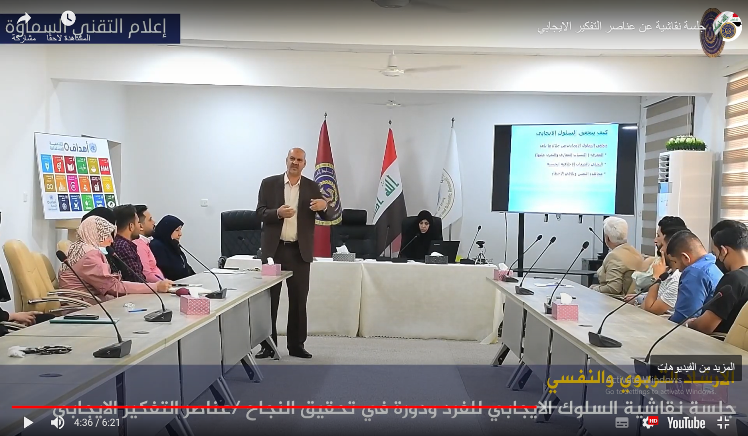

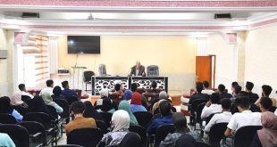

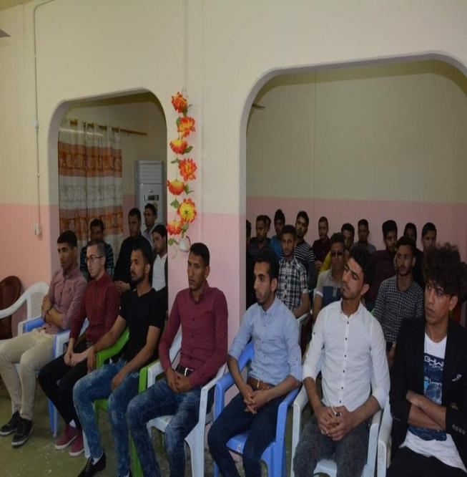
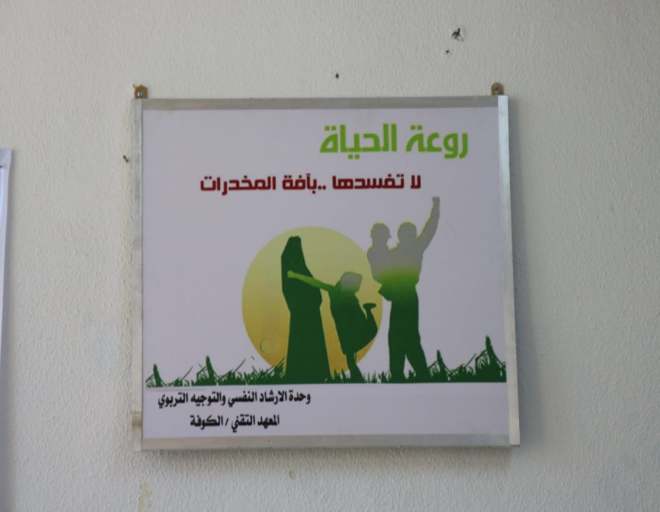

- For more evidence about Healthy Clinic the following :
- Al-Furat Al-Awsat Technical University provides health services support for the entire academic community & Public. Healthy Clinic Photographs
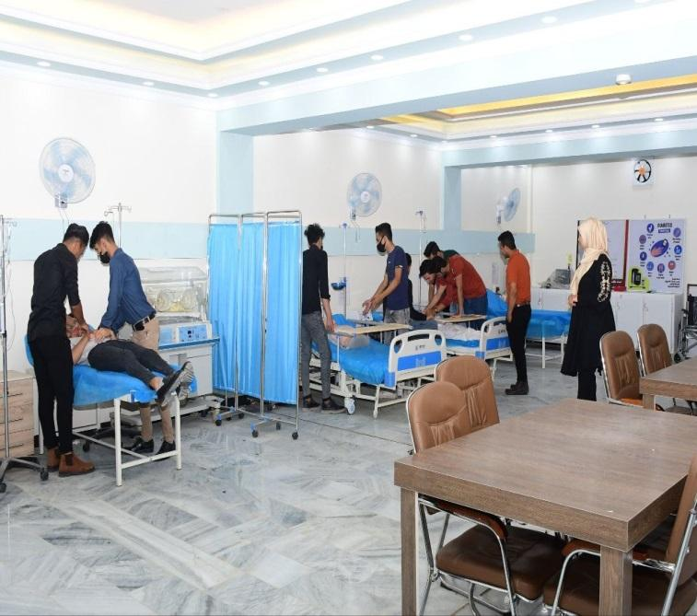
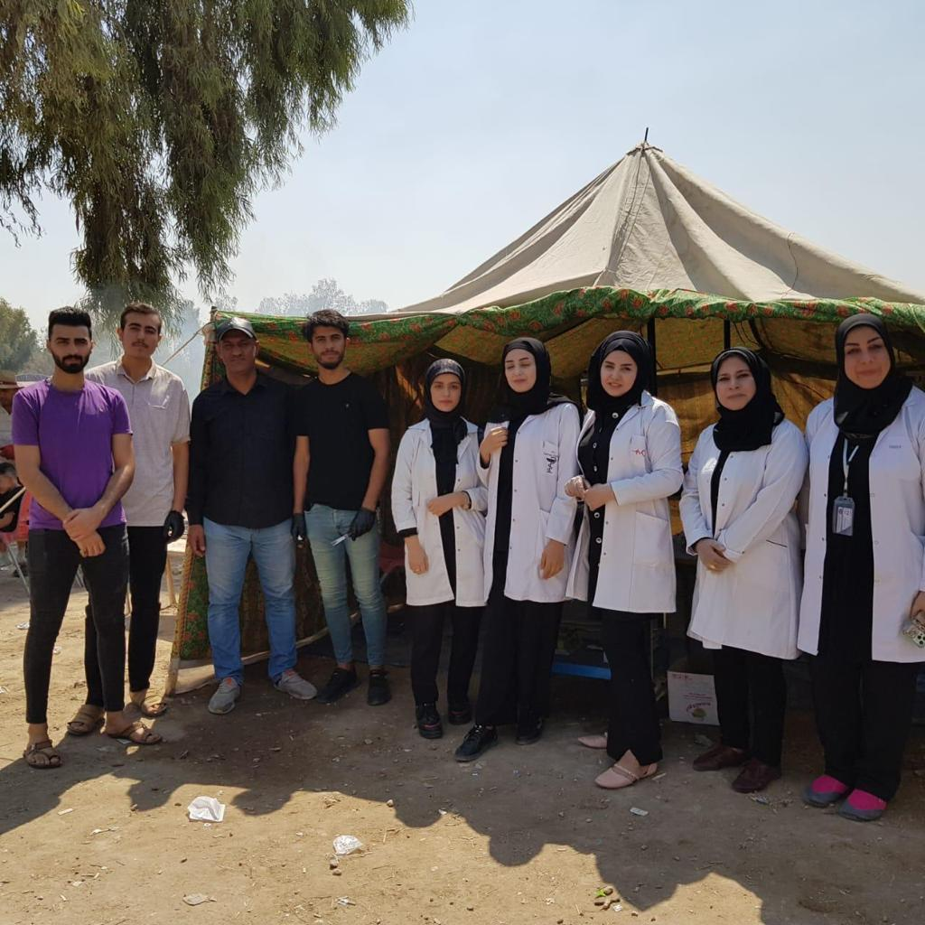

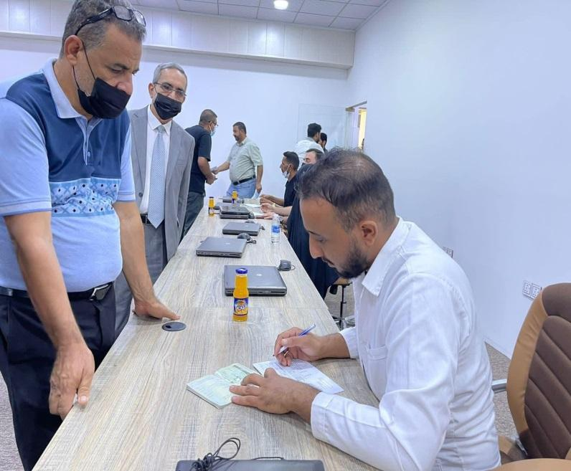
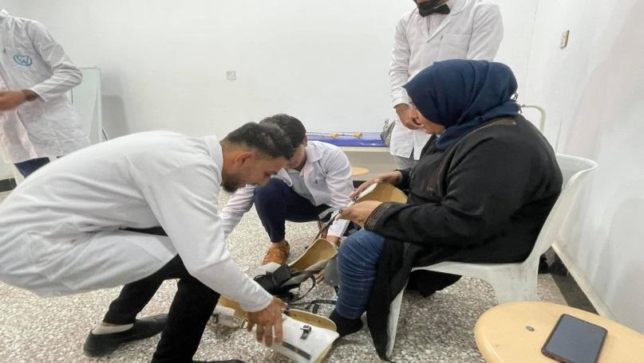
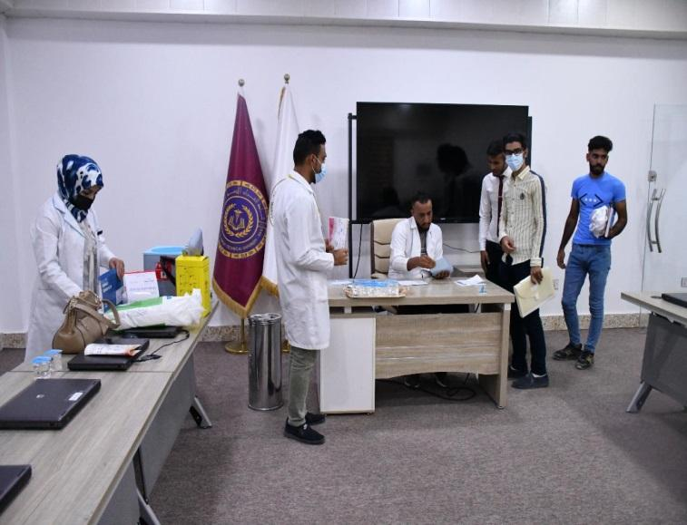
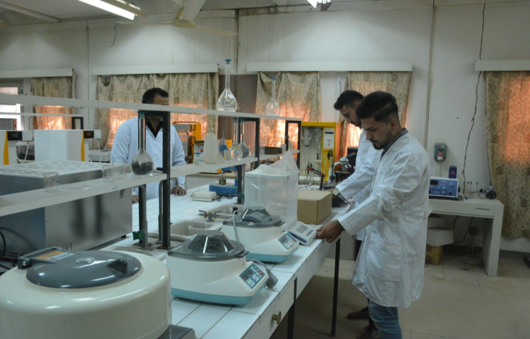

-The President of the Al-Furat Al-Awsat Technical University Opened the closed sports hall in the internal departments for girls in Najaf.The project included the establishment of a closed hall with all the devices and equipment for physical fitness

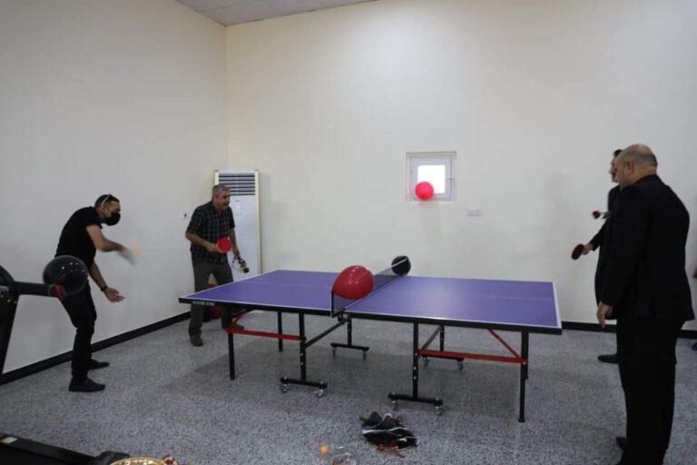

Moreover, Al-Furat Al-Awsat Technical University shares sports facilities with the local community, for instance with colleges or local schools or with the general public, to support their mental and Physical health-care as the following:https://atu.edu.iq/?p=2740

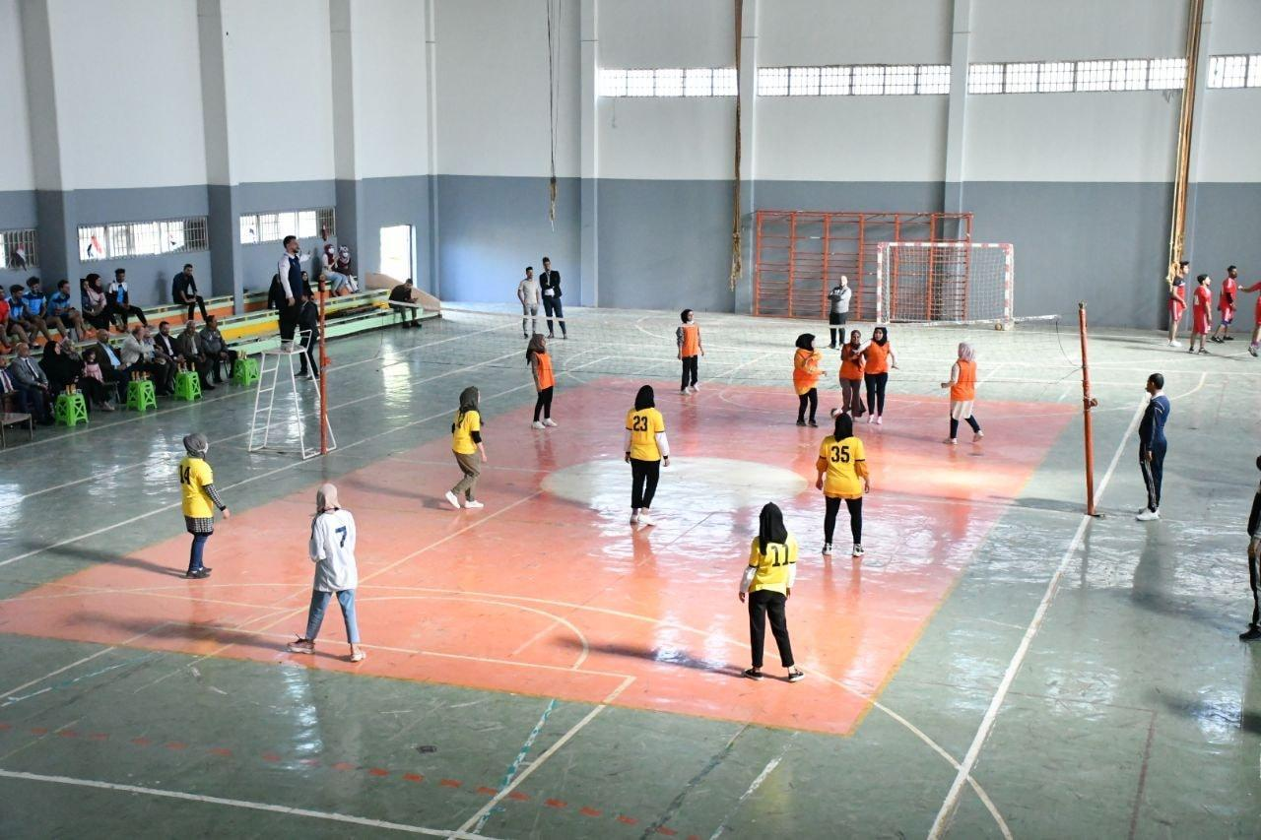
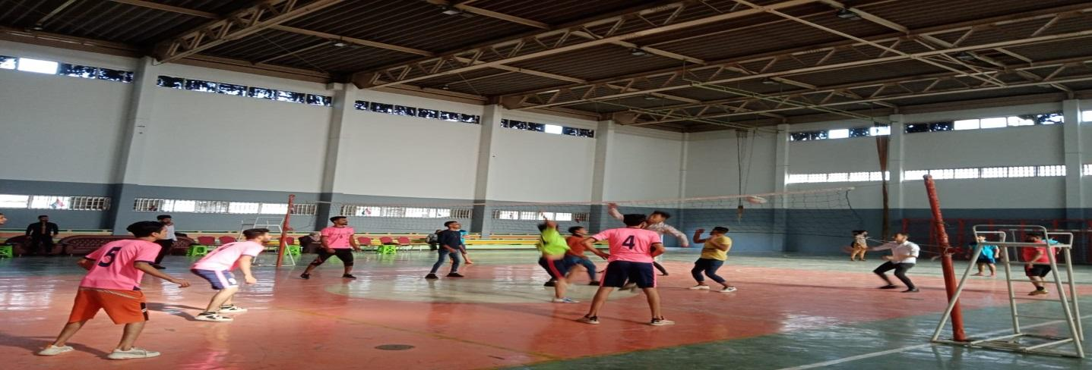
Share Sports Facilities(Al-Furat Al-Awsat Technical University,Iraq)
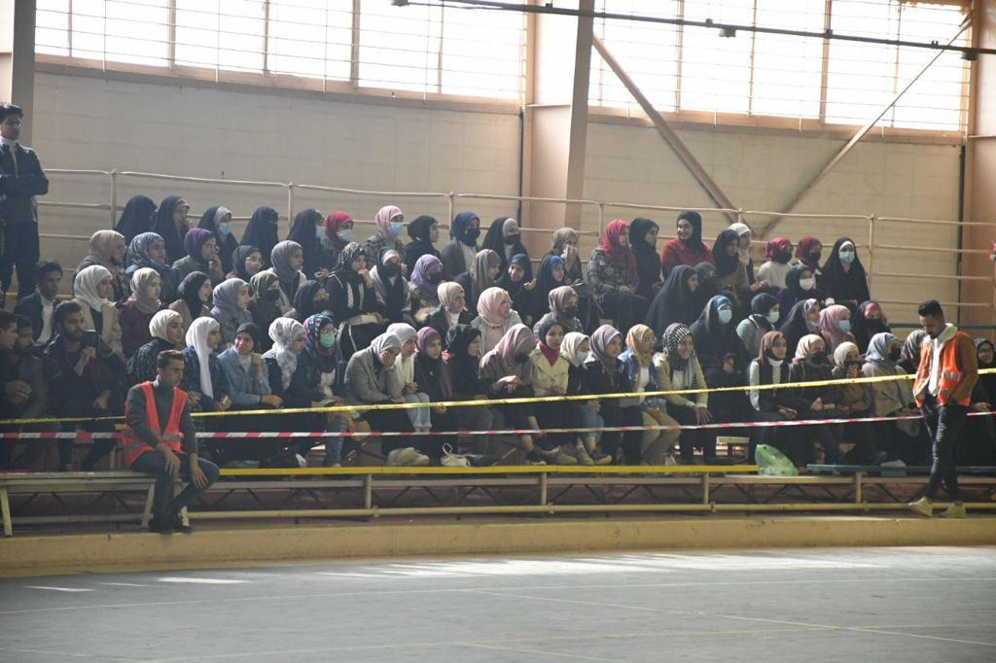
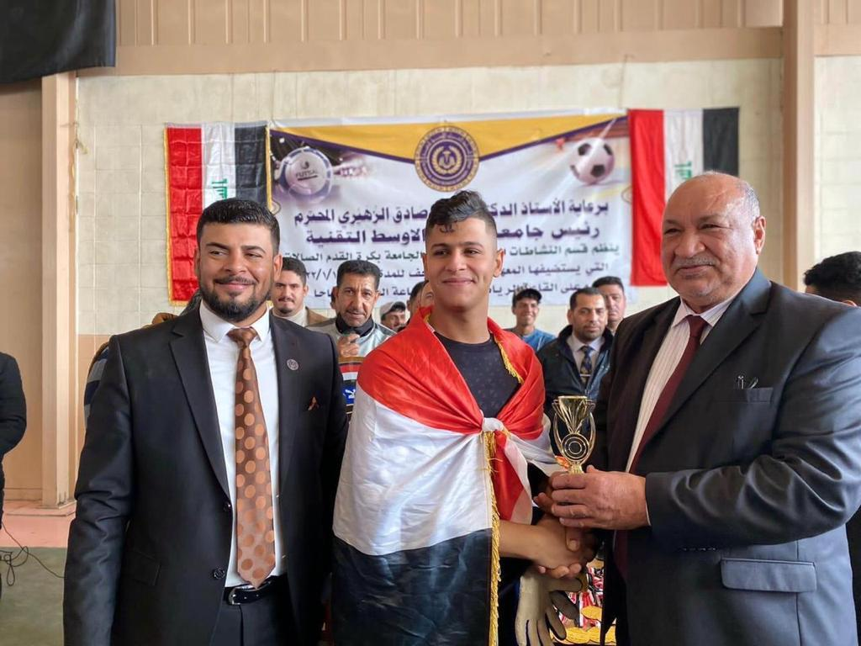

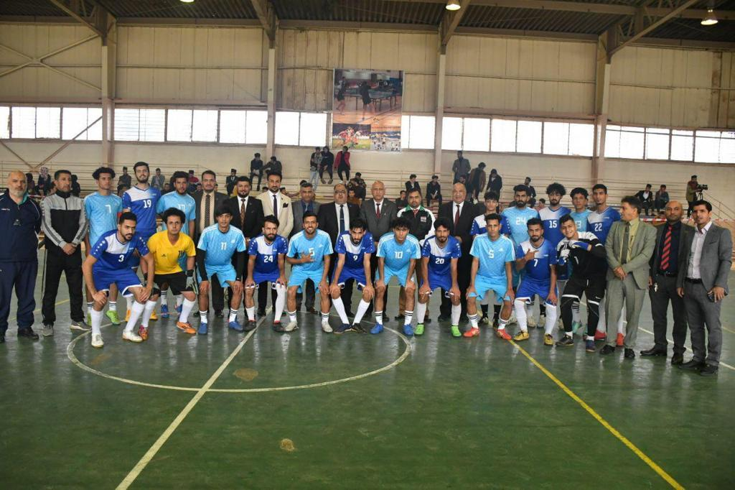

- Establishment of several sports activities in tennis and chess
- https://atu.edu.iq/?p=19009
